Western Mathematics Exams

School Name

Yearly Examination

2015
Year 10
Advanced Mathematics Course

Solutions
Year 10 |  | WME Yearly Advanced Maths | Non Calculator
Section 1 Short Answer Section
ANSWERS
No. | WORKING |  | ANSWER
 | 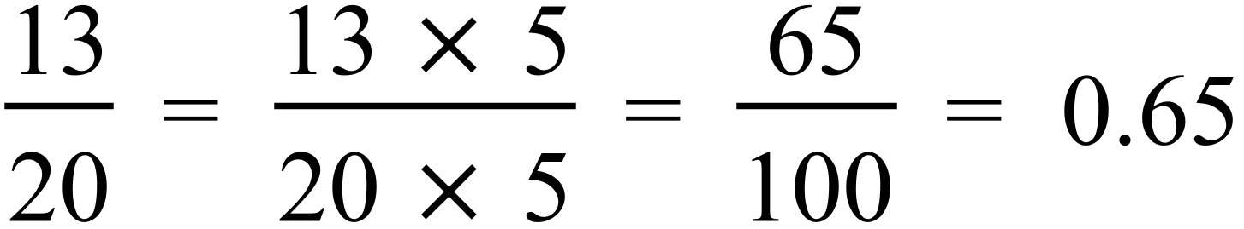  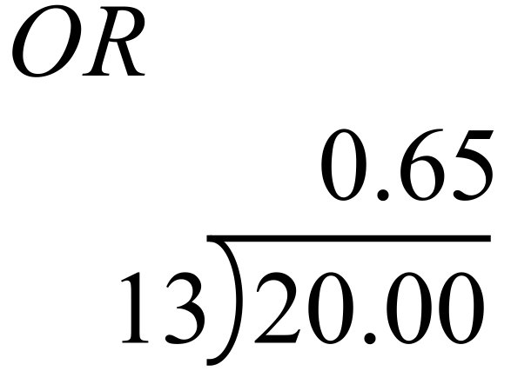 |  | 0.65
 | 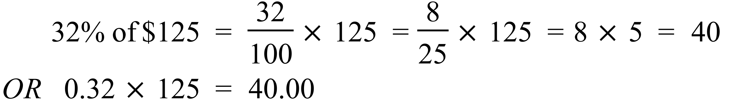 |  | $40
 |  |  | $960
 | 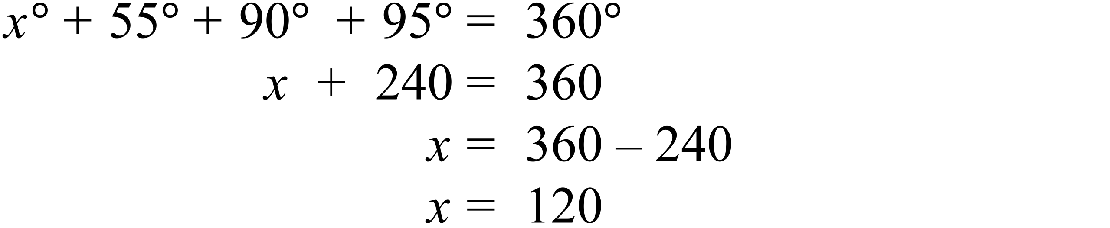 |  | 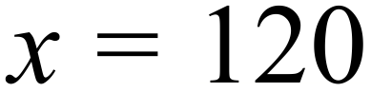
 | 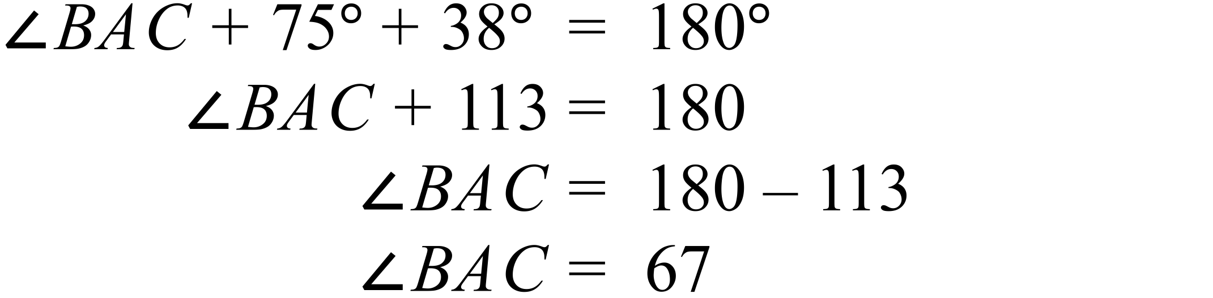 |  | 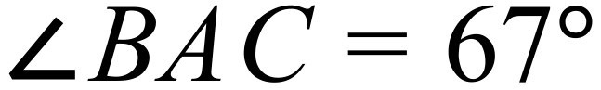
 | 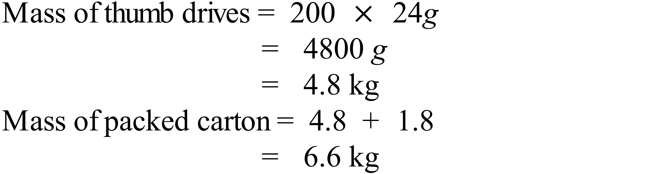 |  | 6.6 kg
 | 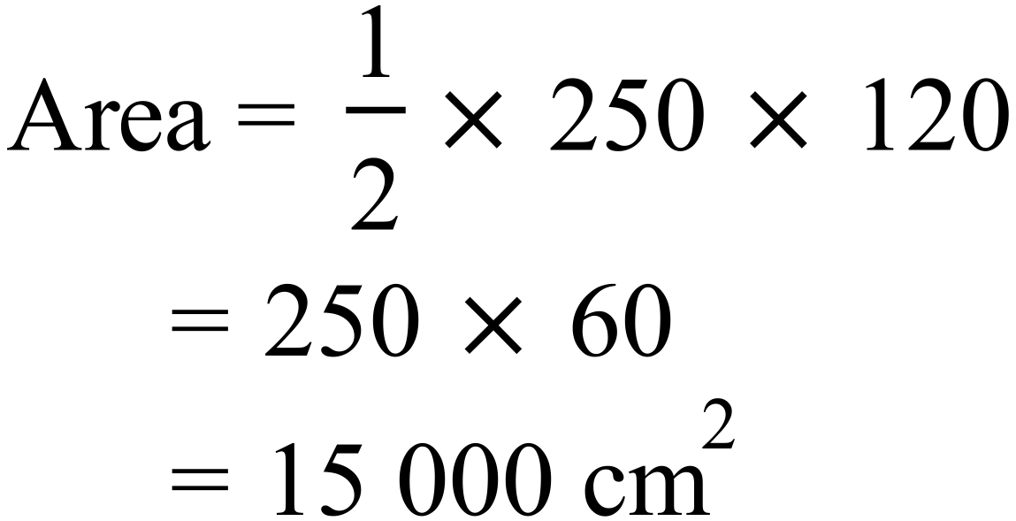 |  | 15 000 cm²
 | 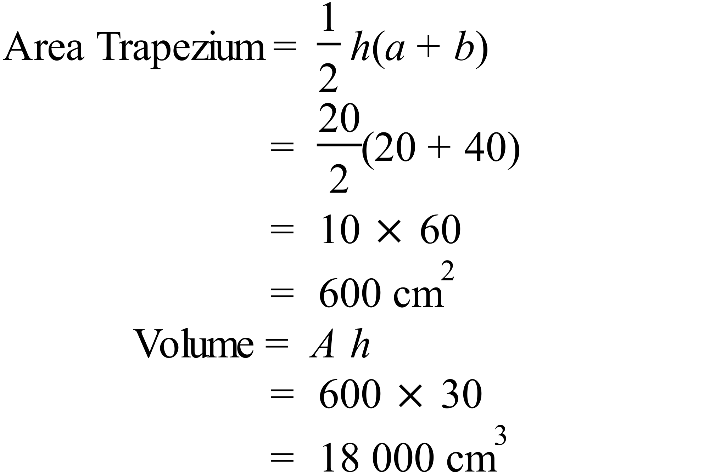 |  | 18 000 cm³
 | 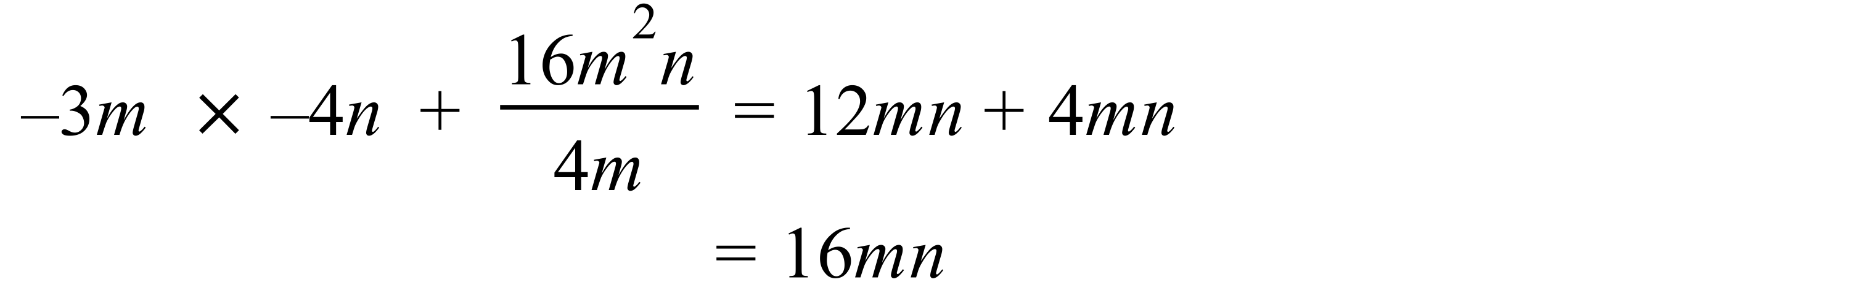 |  | 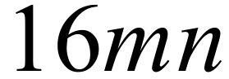
 |  |  | 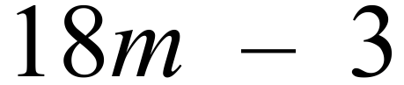
 | 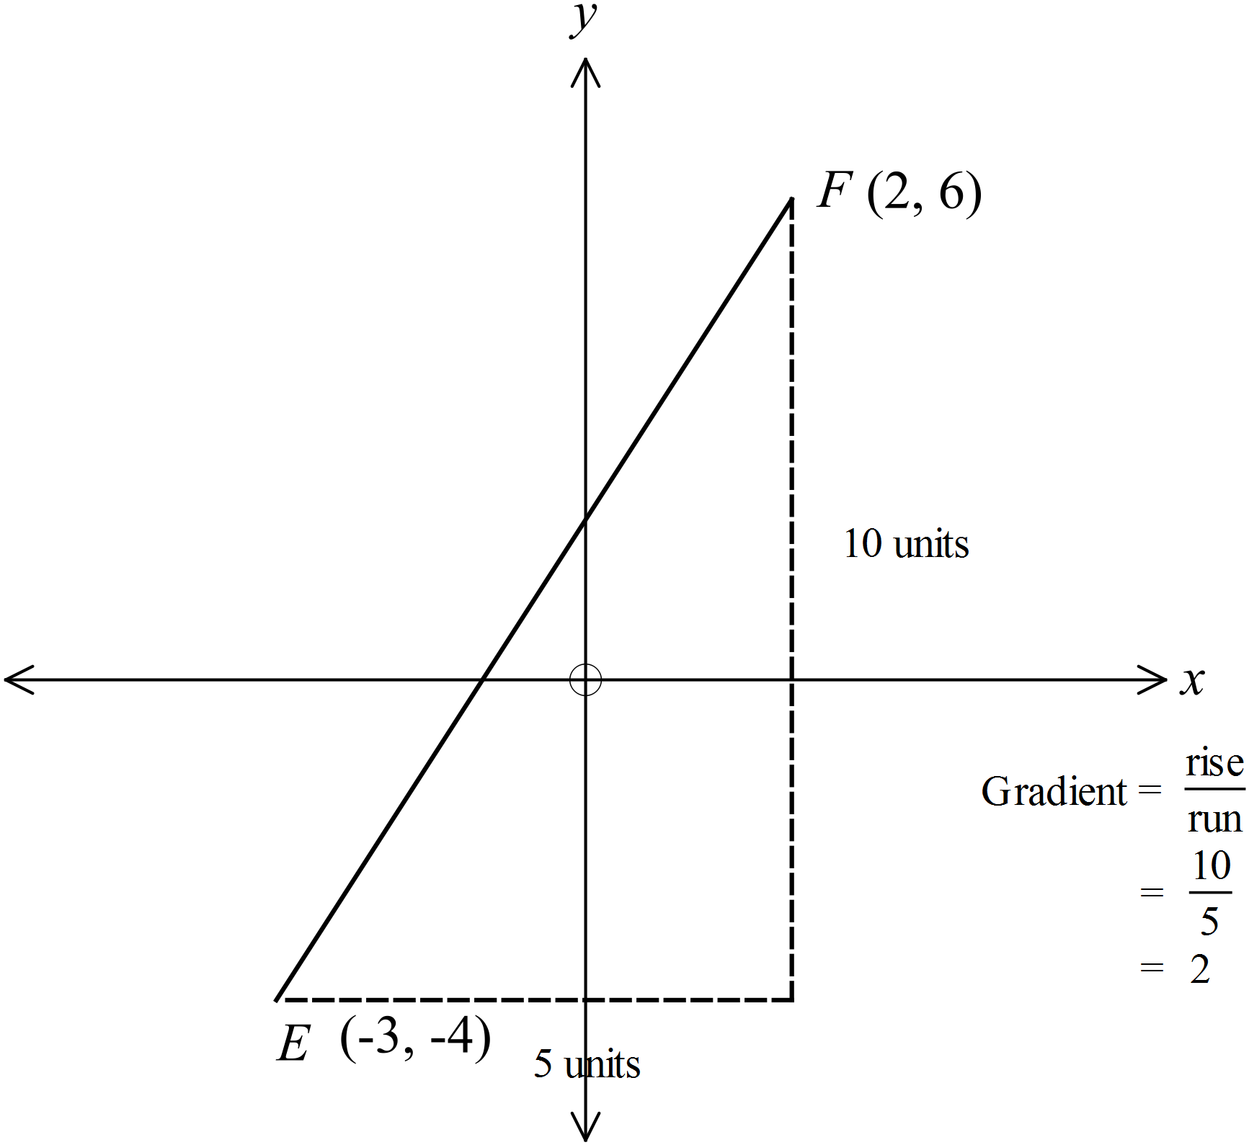 |  | Gradient = 2
 | 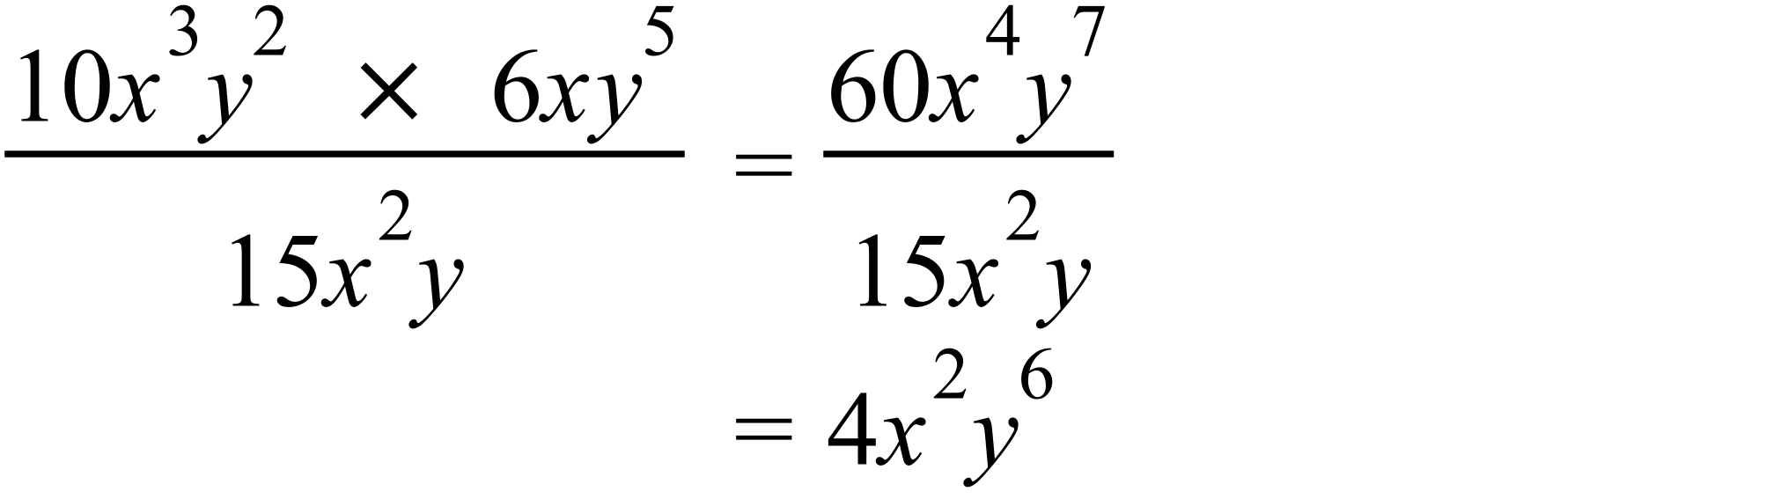 |  | 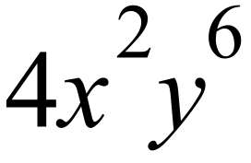
 | 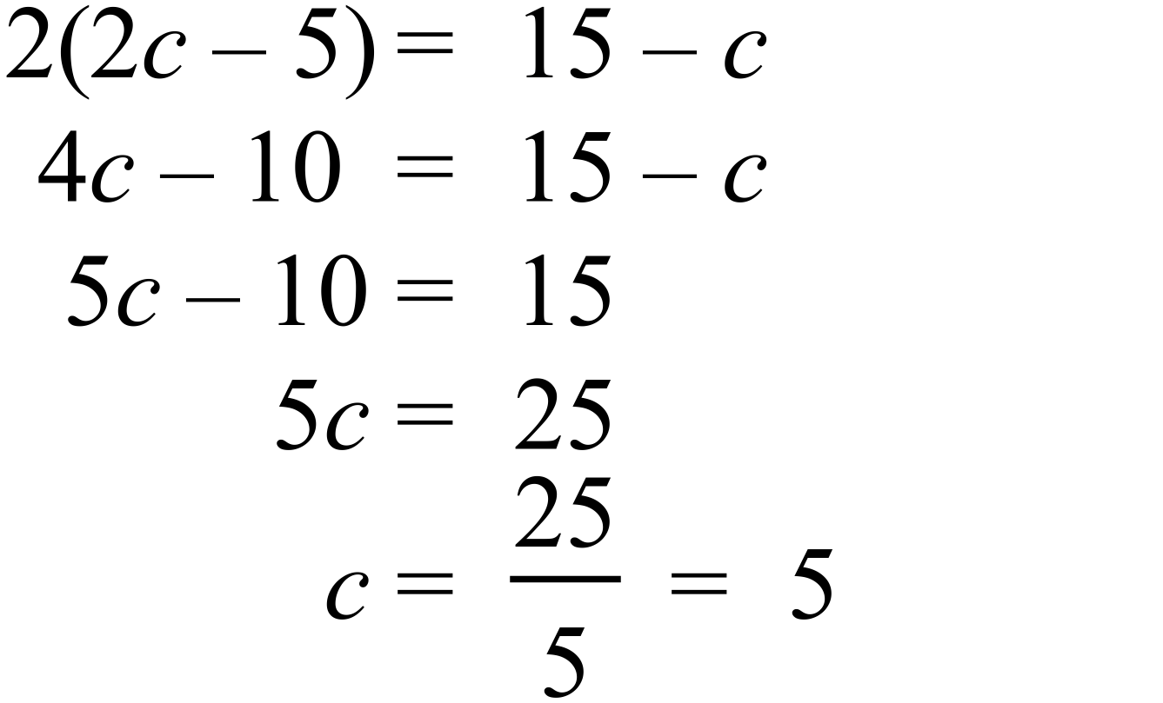 |  | 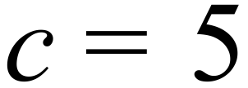
 | 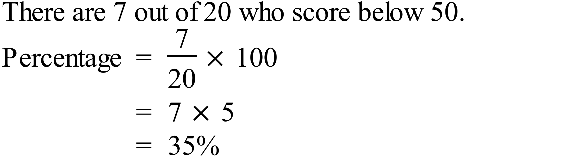 |  | 35%
   |  |  |  |  | ⃝
   |  |  |  |  | ⃝ | ⃝
   |  |  | ⃝ | ⃝ | ⃝ | ⃝
   |  | ⃝ | ⃝ | ⃝ | ⃝ | ⃝
  ⃝ | ⃝ | ⃝ | ⃝ | ⃝ | ⃝ | ⃝ | ⃝
  46 | 47 | 48 | 49 | 50 | 51 | 52 | 53
 | 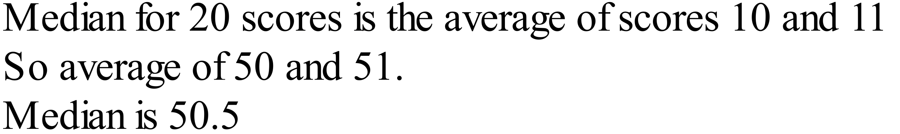 |  | 50.5
 | 12.5 : 50 = 125 : 500  = 5 : 20  = 1 : 4 |  | 1 : 4
 | 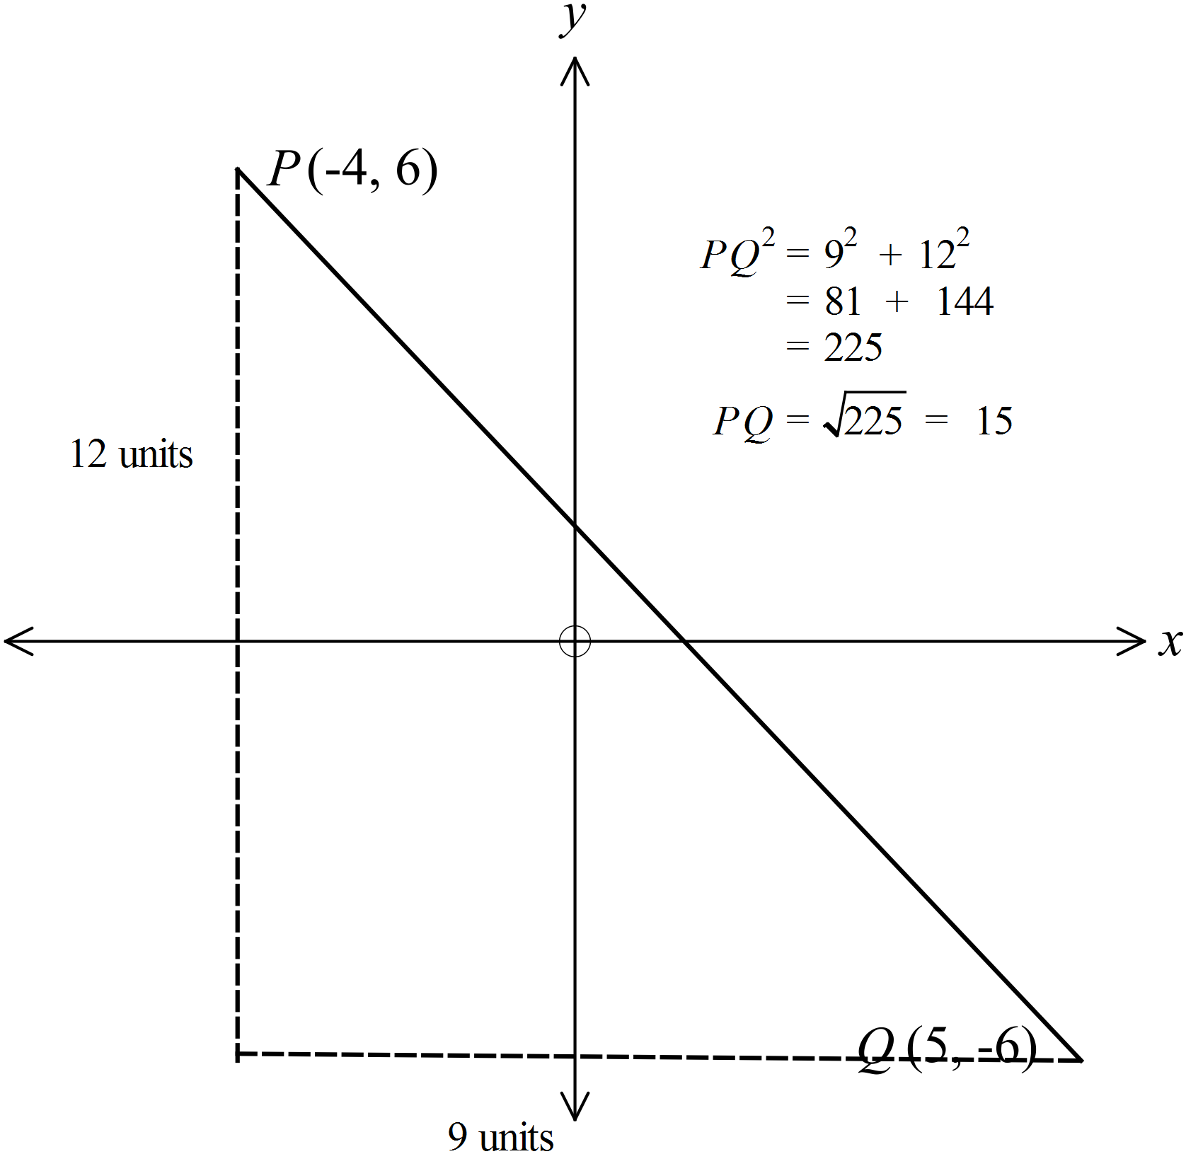 |  | 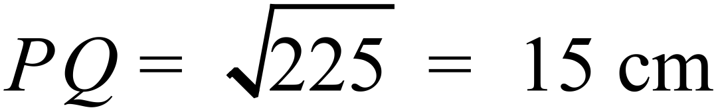
 | 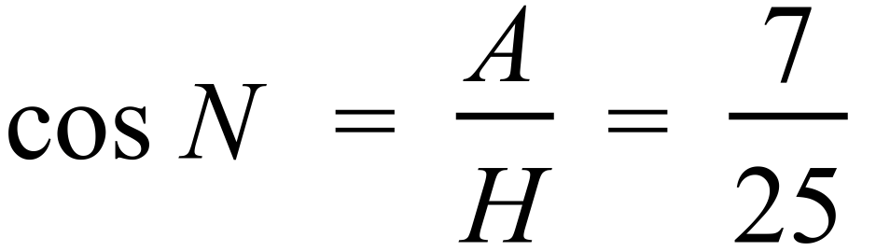 |  | 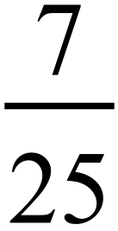
 | 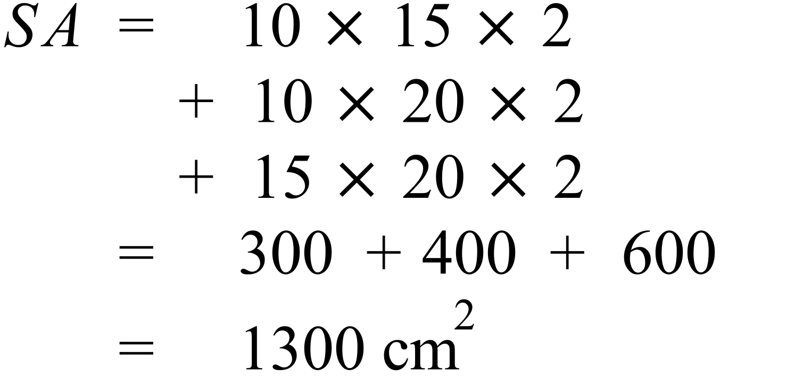 |  | 1300 cm²
 | 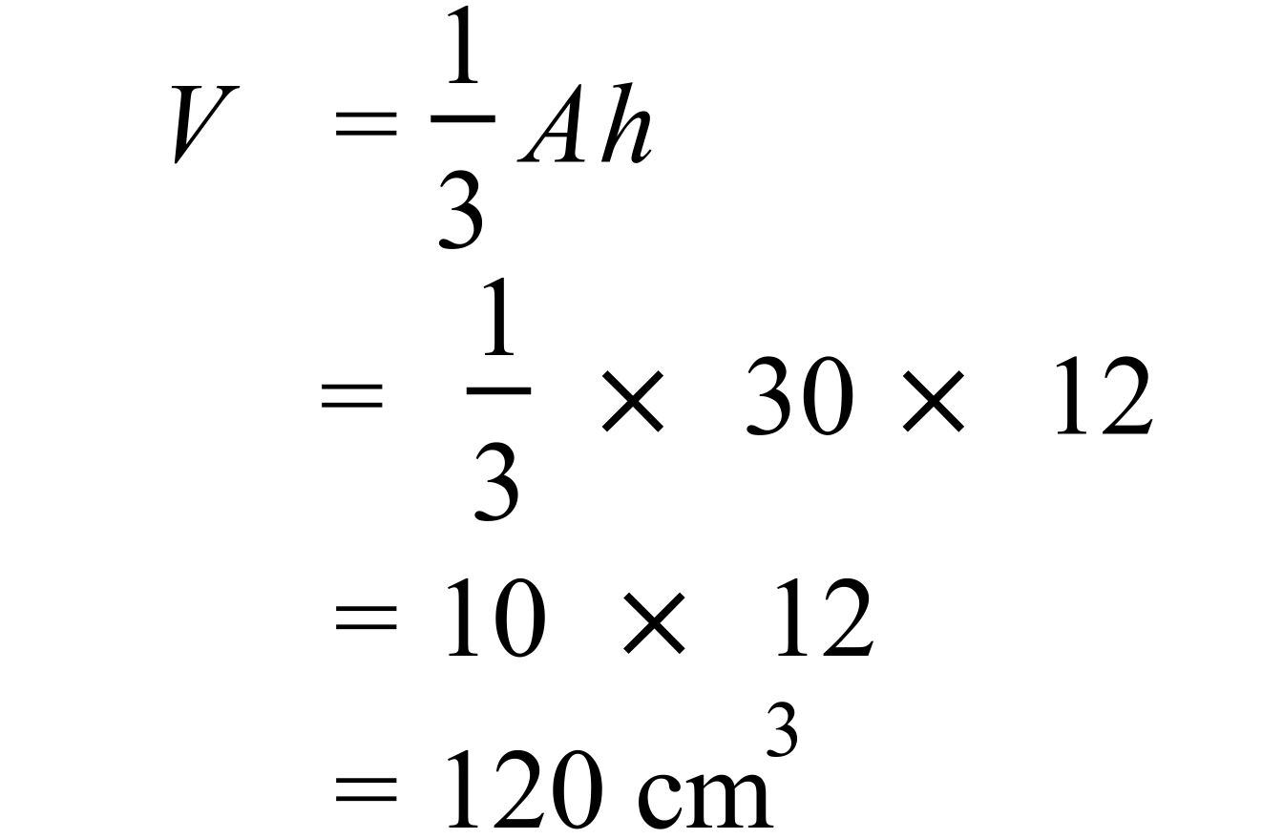 |  | 120 cm³
The points A’ and B’ need to be located by any reasonable construction method and the triangle drawn and labelled.
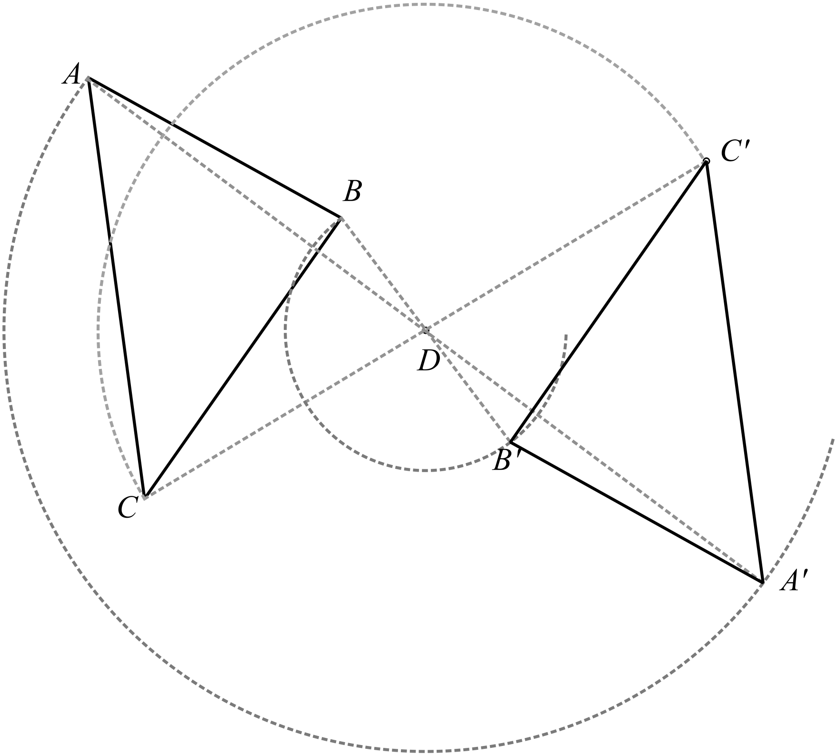

 | There are 5 black counters, 5 patterned counters and 4 white counters, so both black and patterned have a 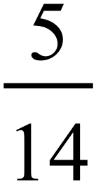 chance of being picked up. |  | Black and Patterned
 | 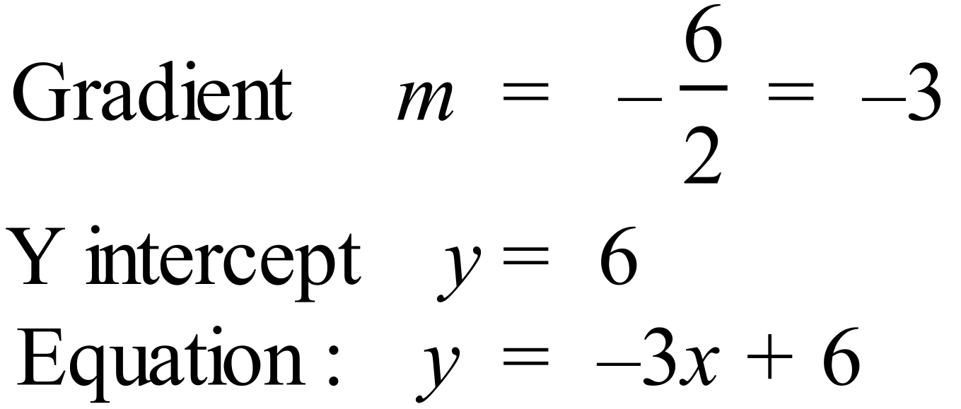 |  | 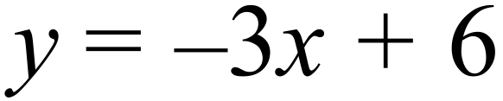
 | 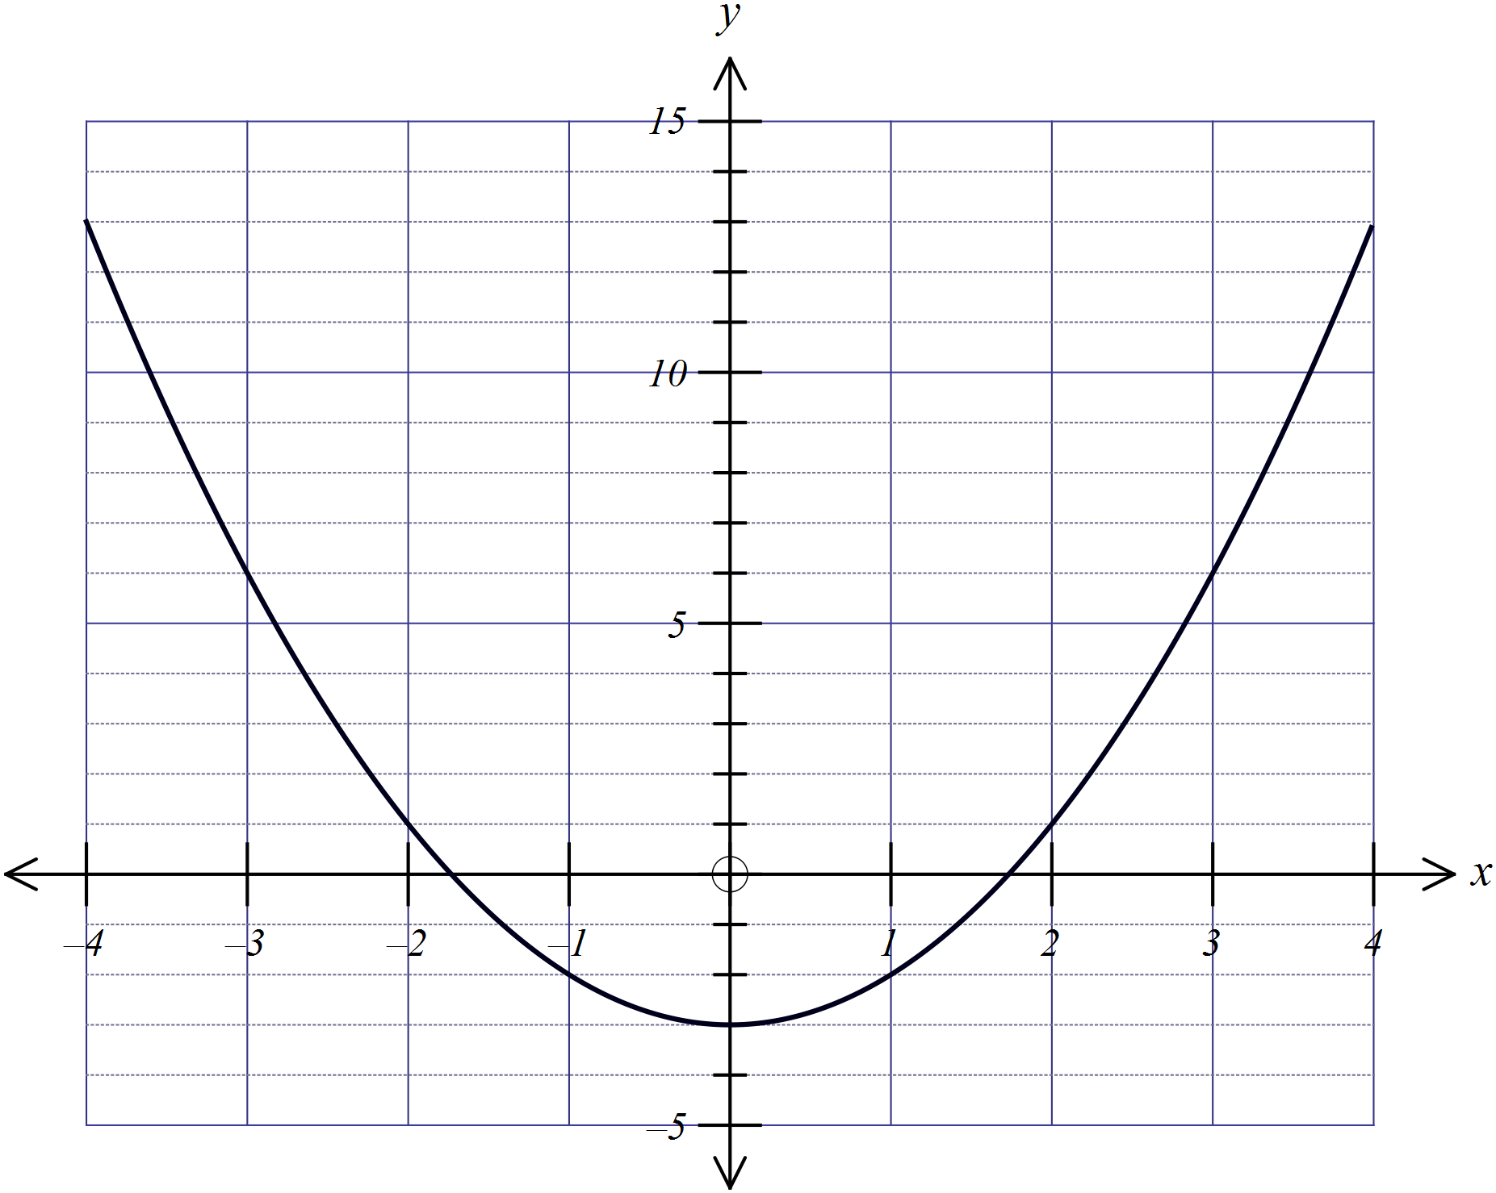
 | 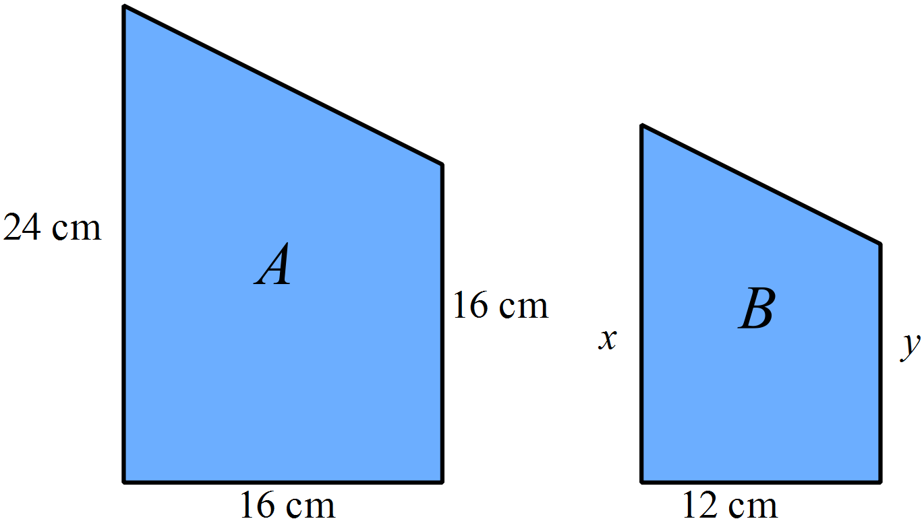  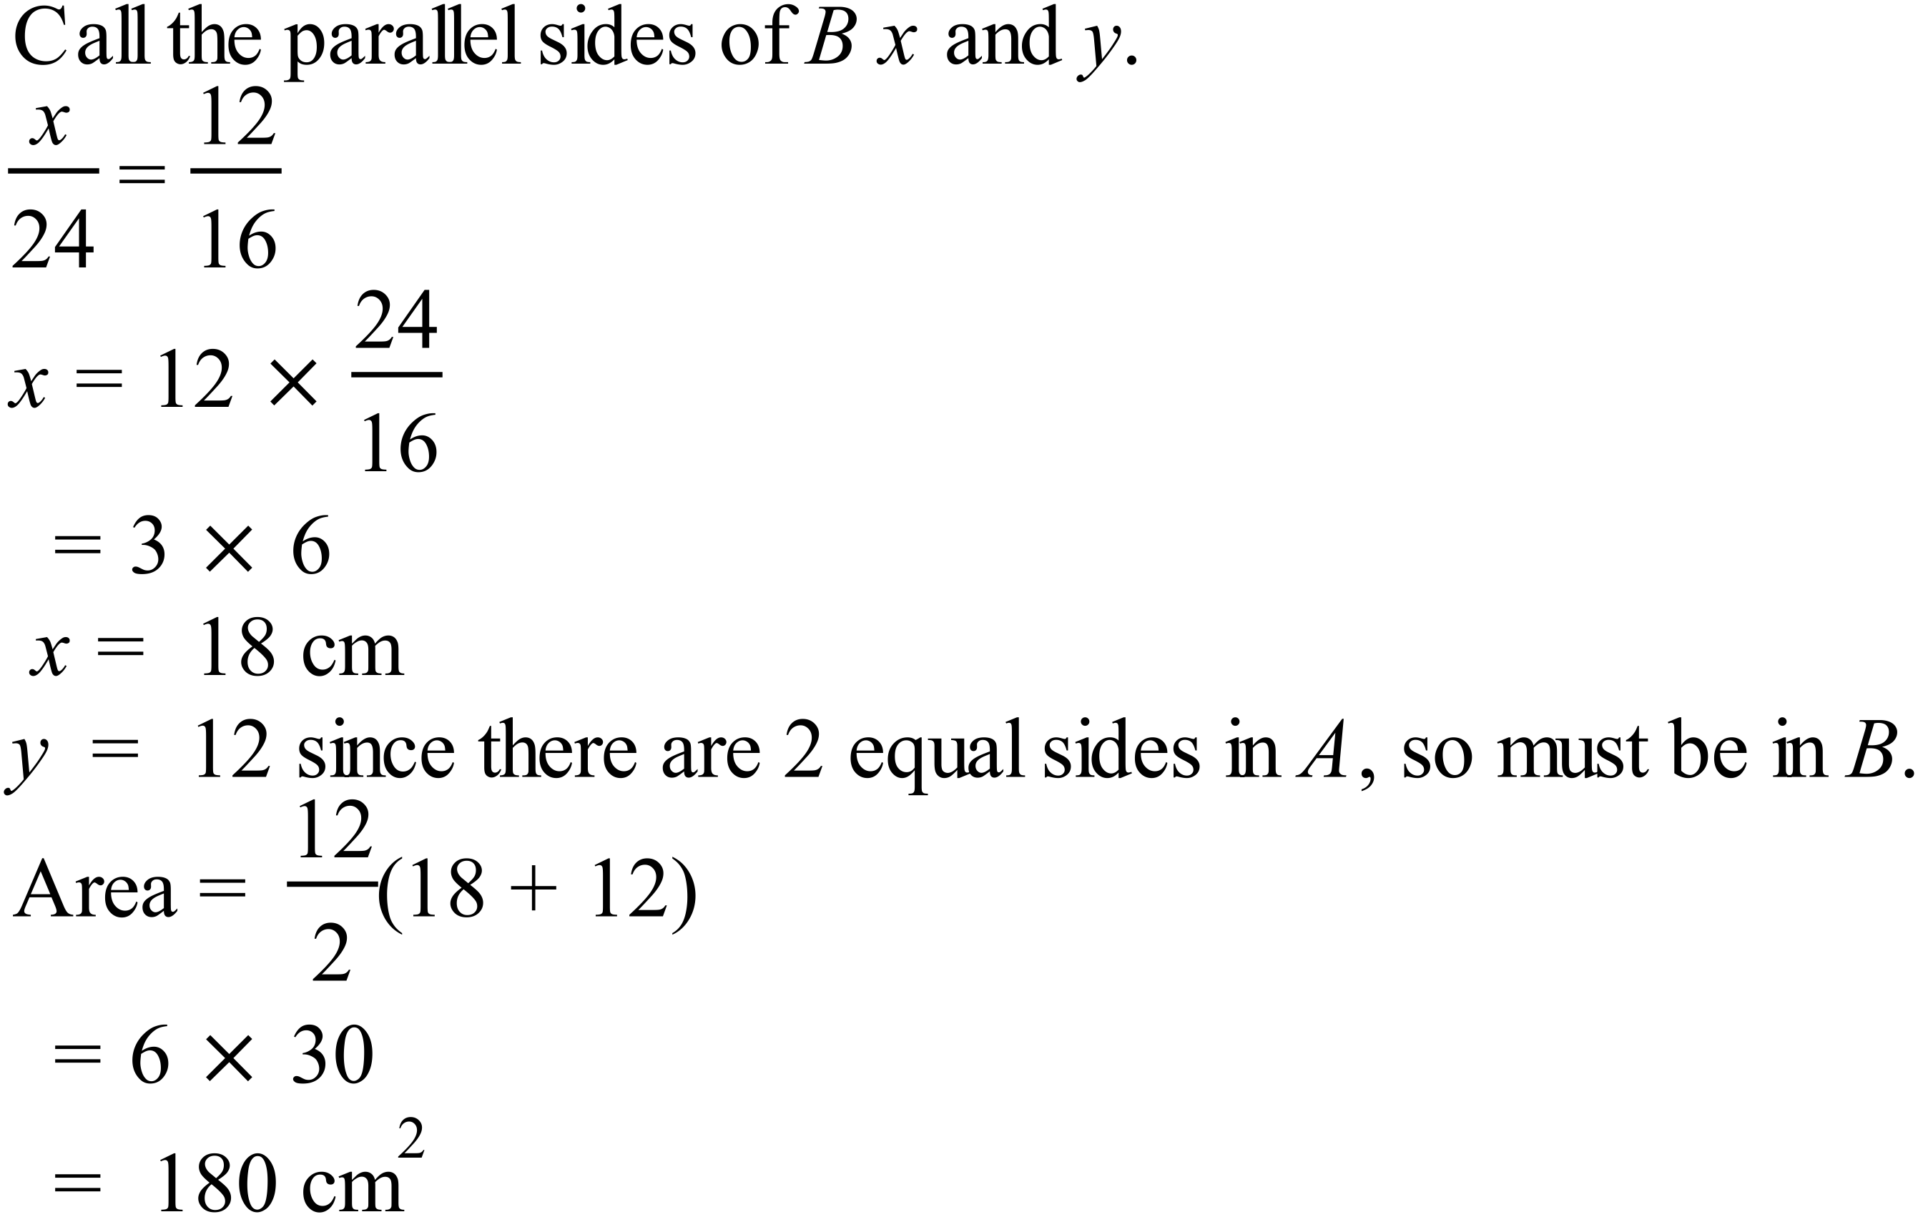  Can also be done by ratio of areas.  Ratios of Length A : Length B = 4:3  So ratio Area A : Area B = 16:9  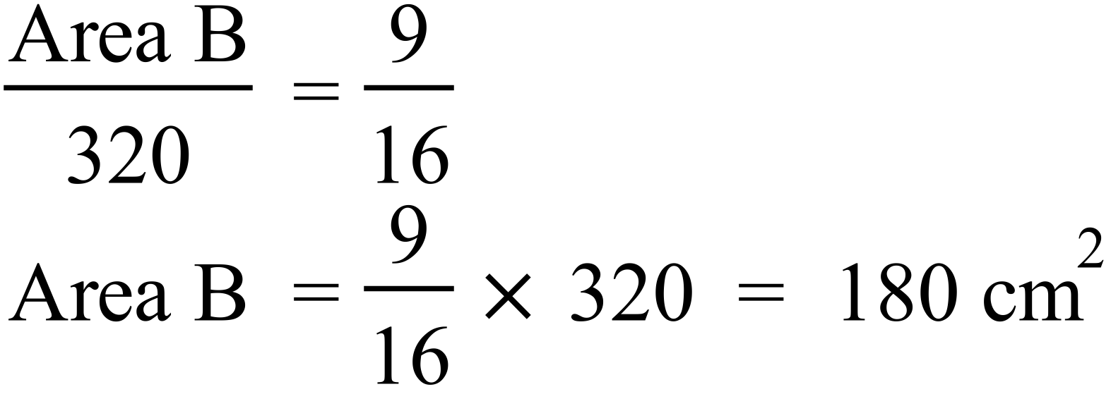 |  | 180 cm²

Year 10 |  | WME Yearly Advanced Maths | Calculator Allowed
Section 2 Part A Multiple Choice Section
ANSWERS
No. | WORKING |  |  | ANSWER
 | 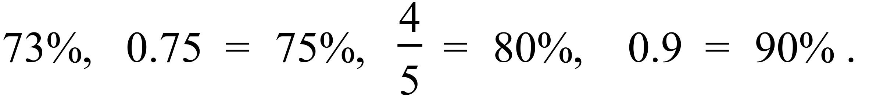 |  |  | C
 | 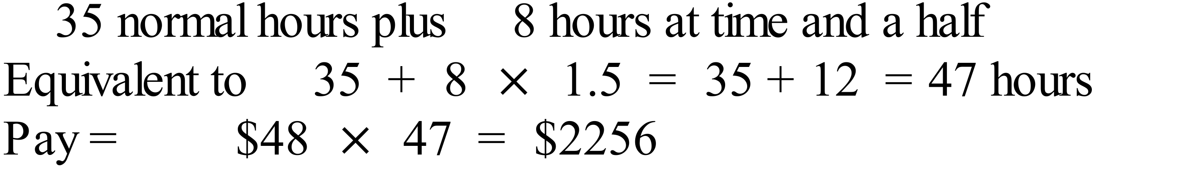 |  |  | B
 | 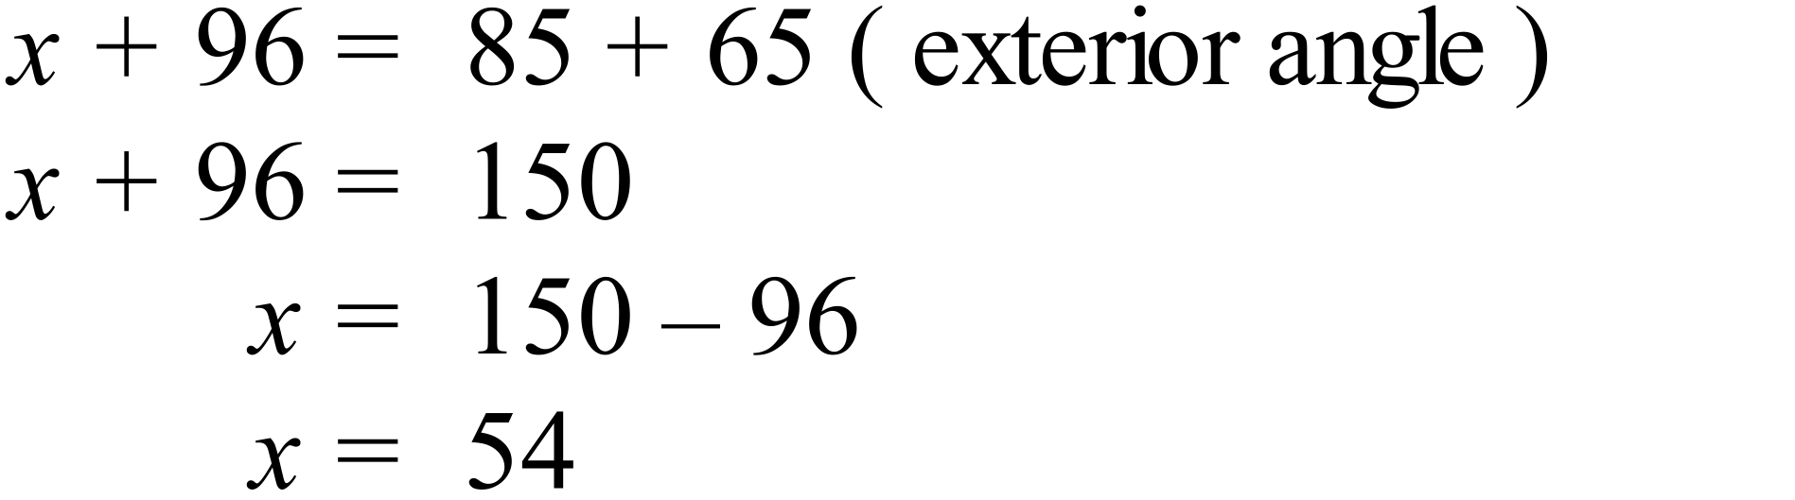 |  |  | B
 | 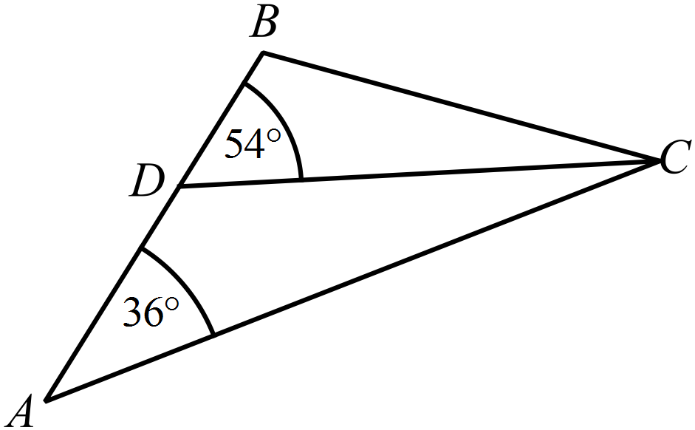  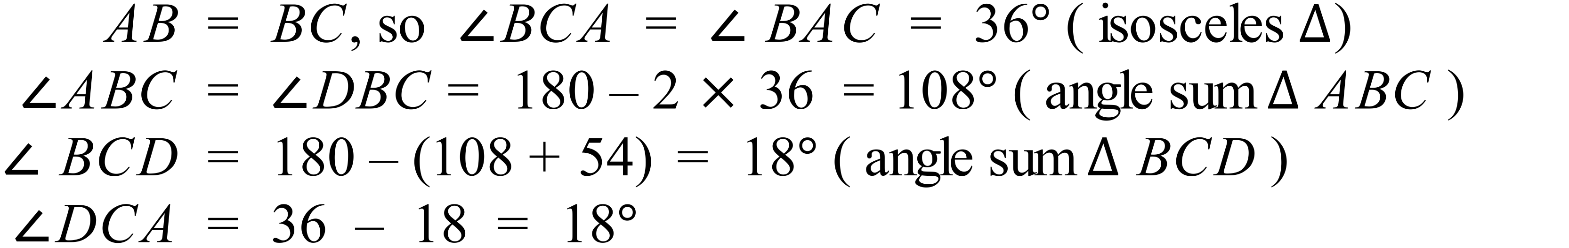 |  |  | A
 | 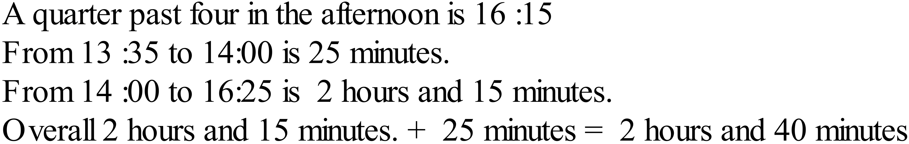 |  |  | D
 | 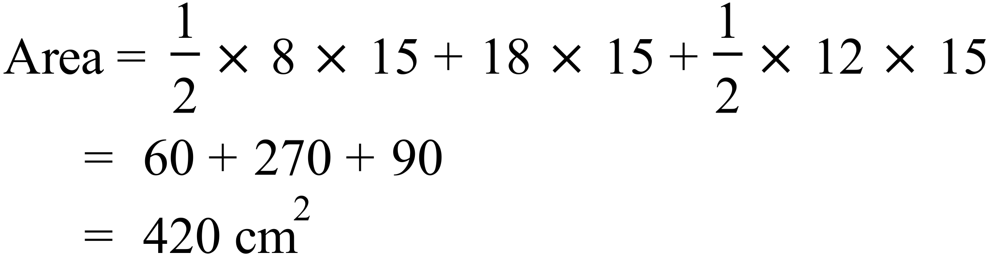 |  |  | C
 | 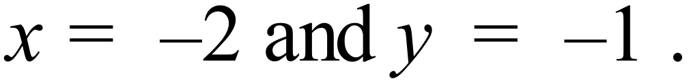  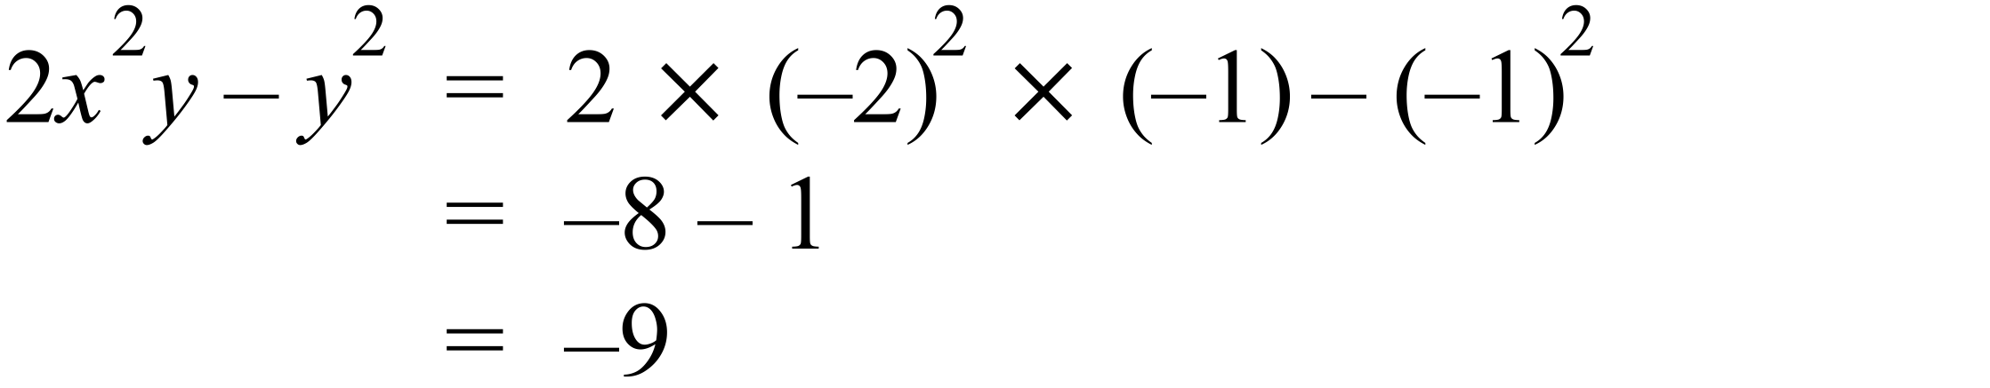 |  |  | A
 | 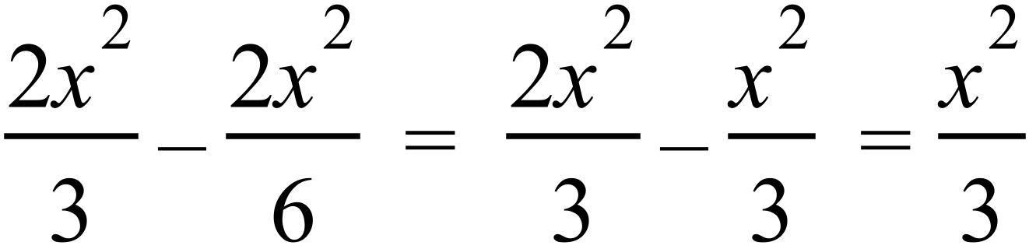 |  |  | B
 | 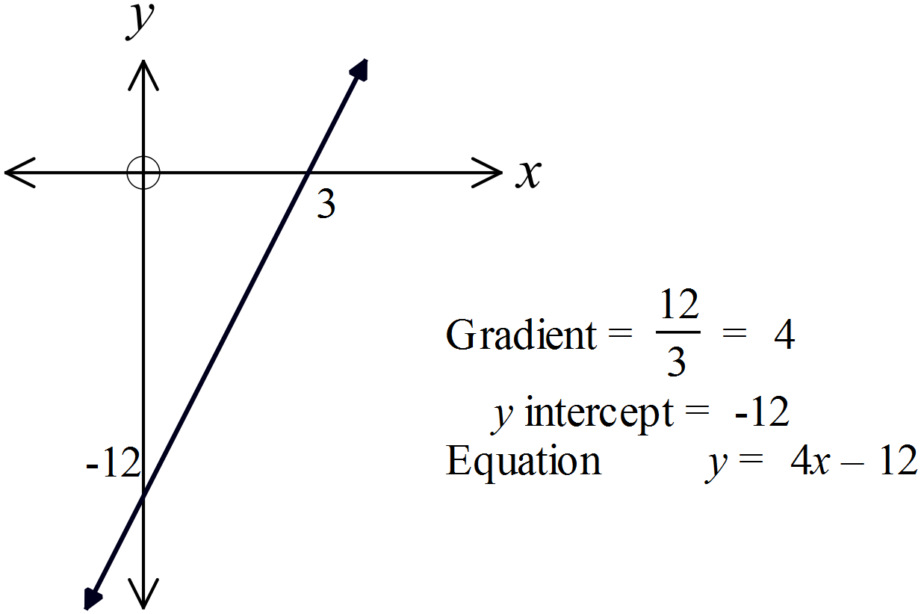 |  |  | D
 |  |  |  | C
 | 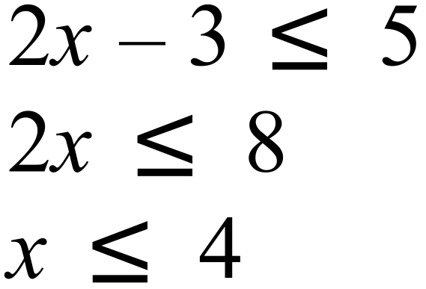  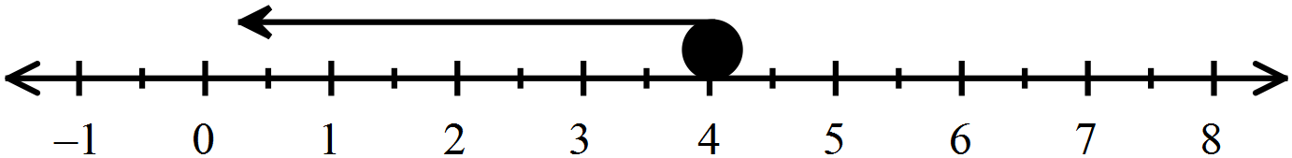 |  |  | C
 | The data is numerical and since there are points, it is discrete. |  |  | C
 | Q2 (median) = 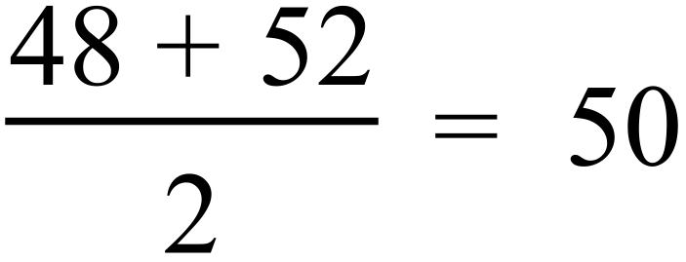  Q1 (1st quartile ) = 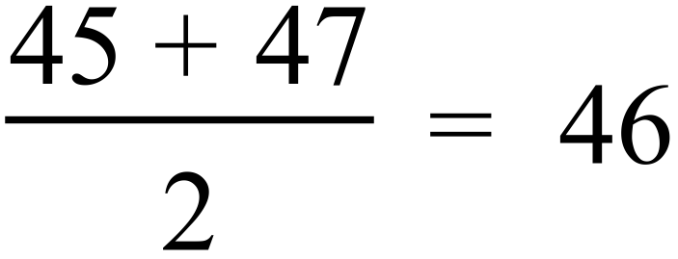  Q3 (3rd quartile) = 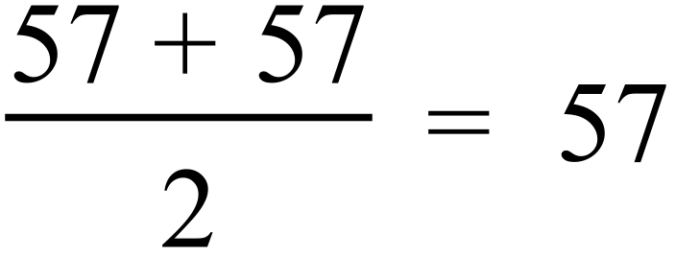  Interquartile range = 57 – 46 = 11 |  |  | B
  2 | 2 | 8 |  |  |  |  |  |  |  |  | Q1
  3 | 7 | 9
  4 | 5 | 7 | 8 | 8 | 8 | 8 |  |  |  |  | Q2
  5 | 2 | 4 | 5 | 5 | 7 | 7 | 8 | 8 | 9 |  | Q3
  6 | 0
 | P (56 or greater) = 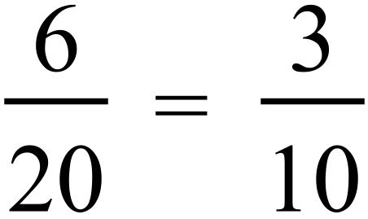  P (less than 56) = 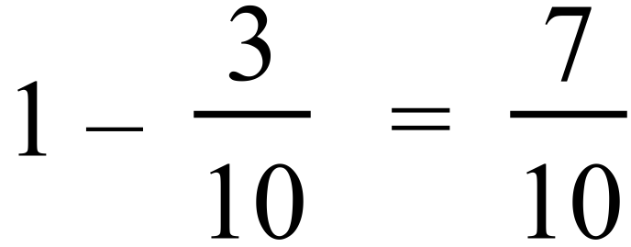 |  |  | D
 | 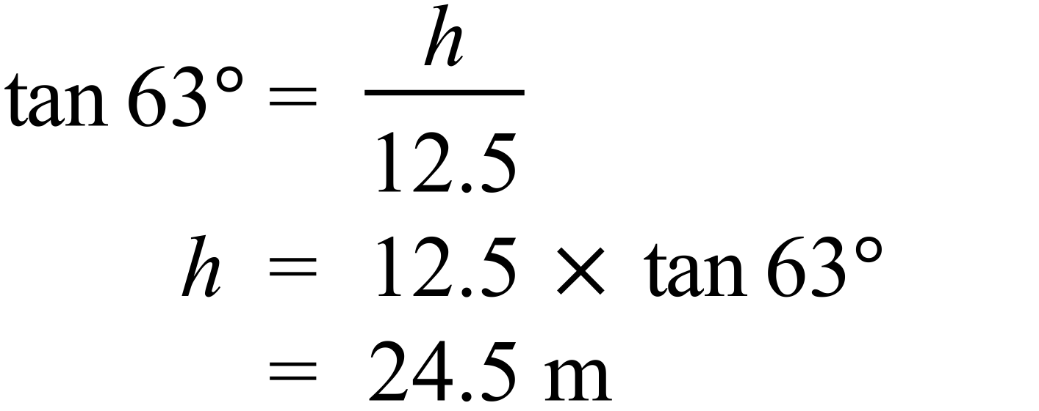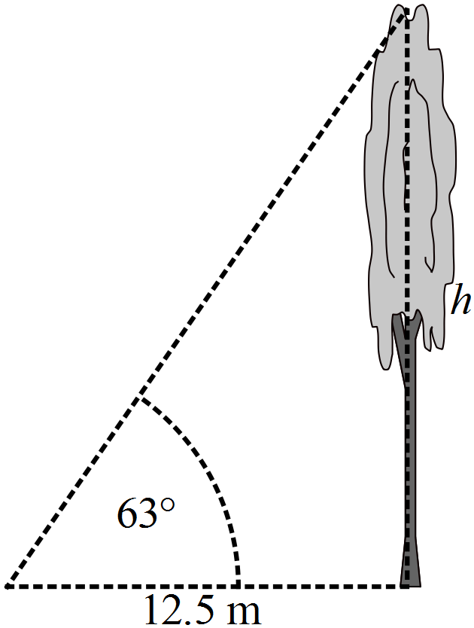 |  |  | D
 | 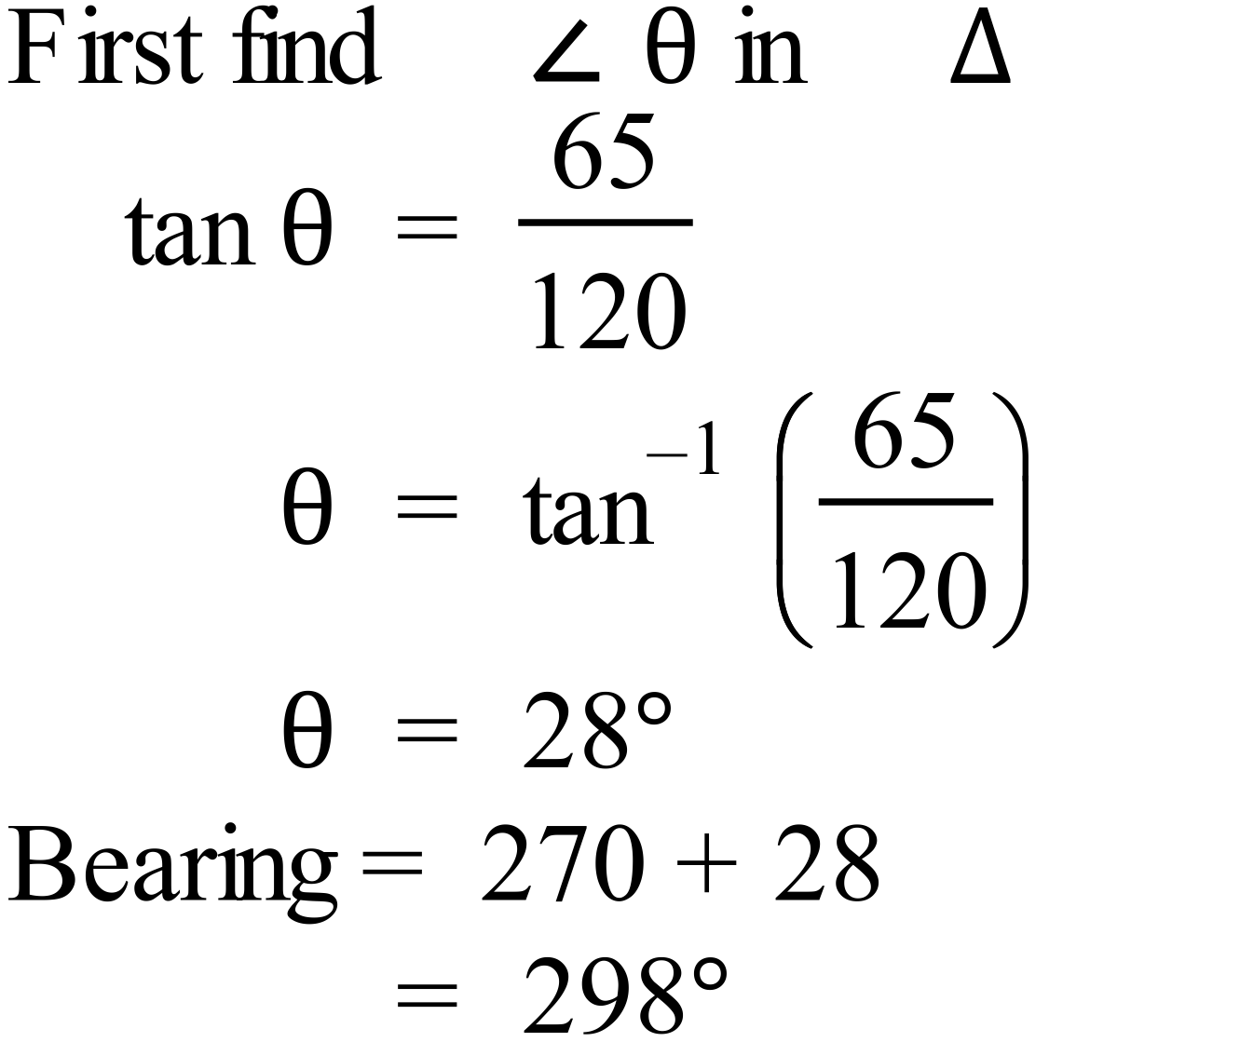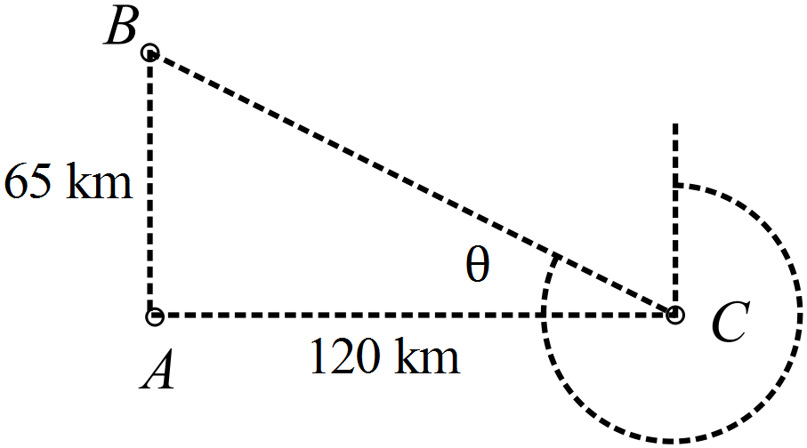 |  |  | D
 | 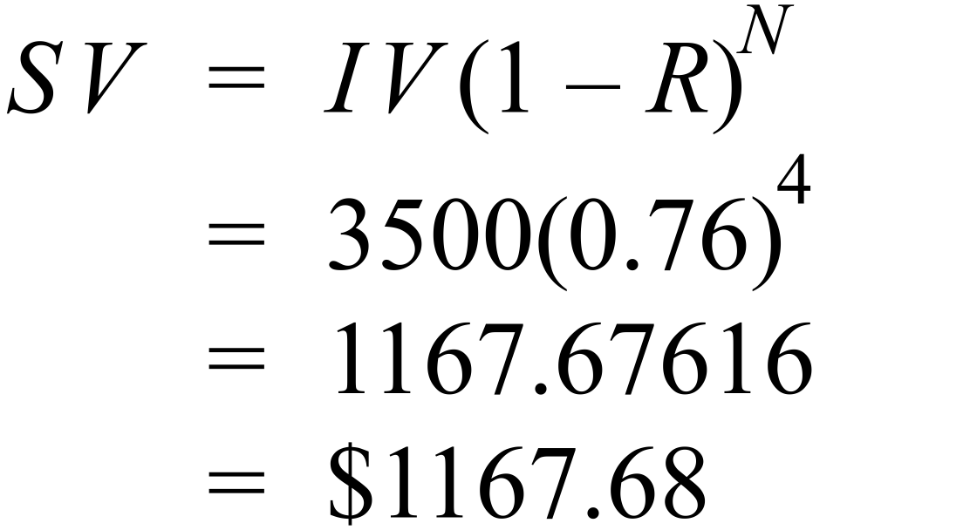 |  |  | A
 | 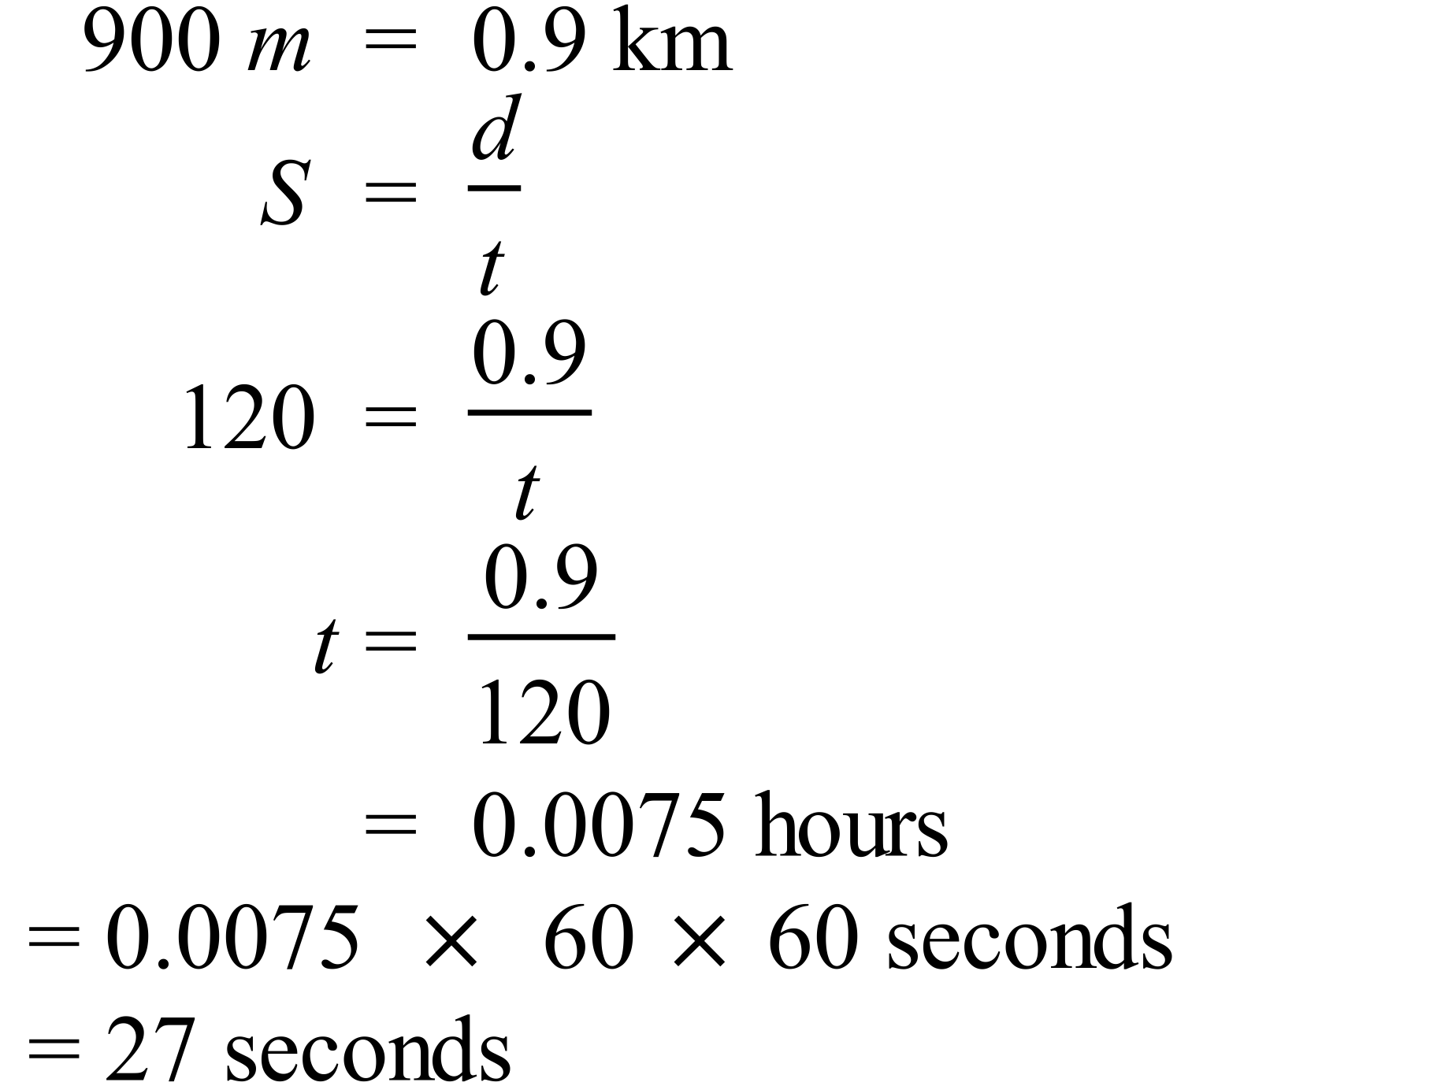 |  |  | A
 | 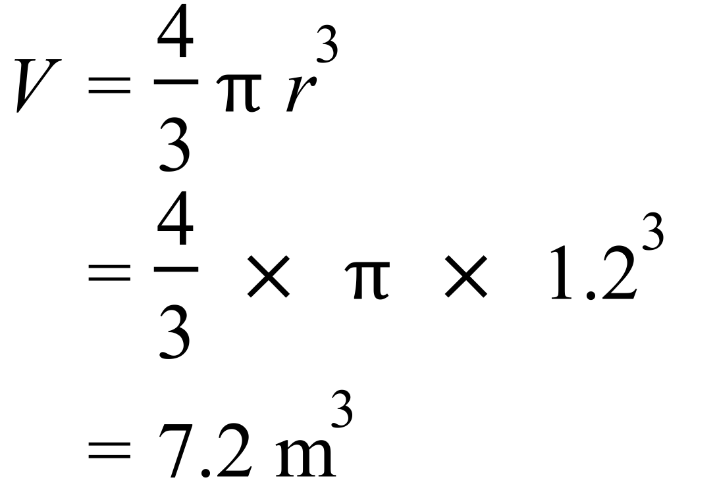 |  |  | A
 | 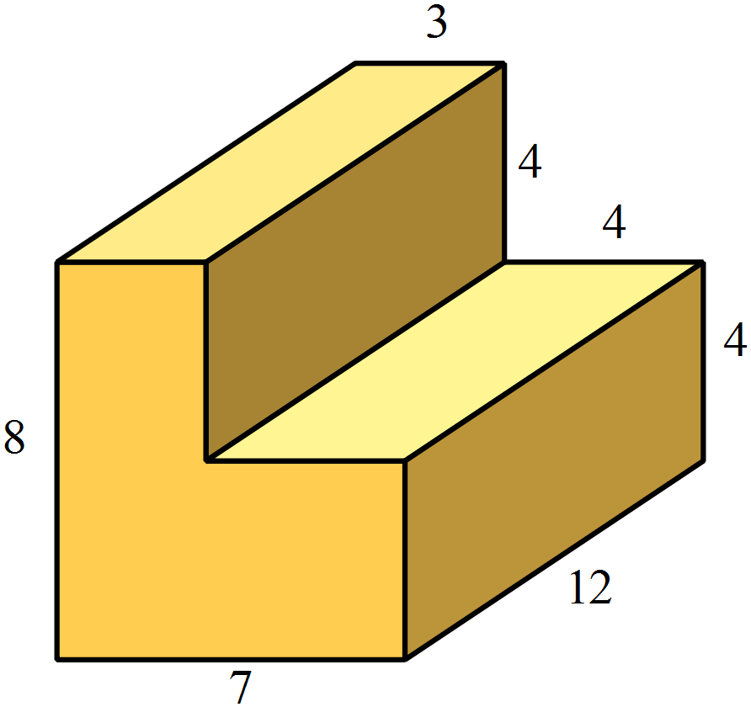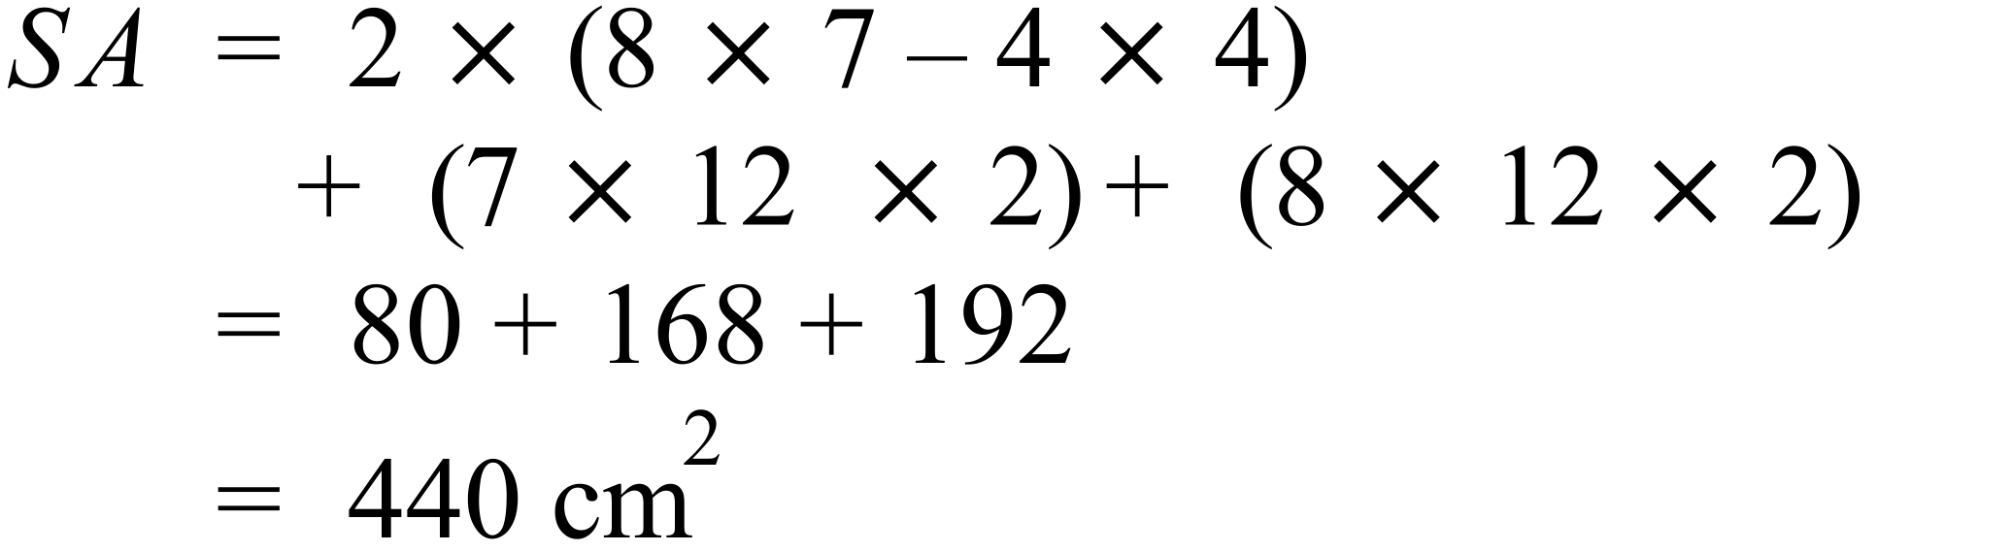 |  |  | B
 | 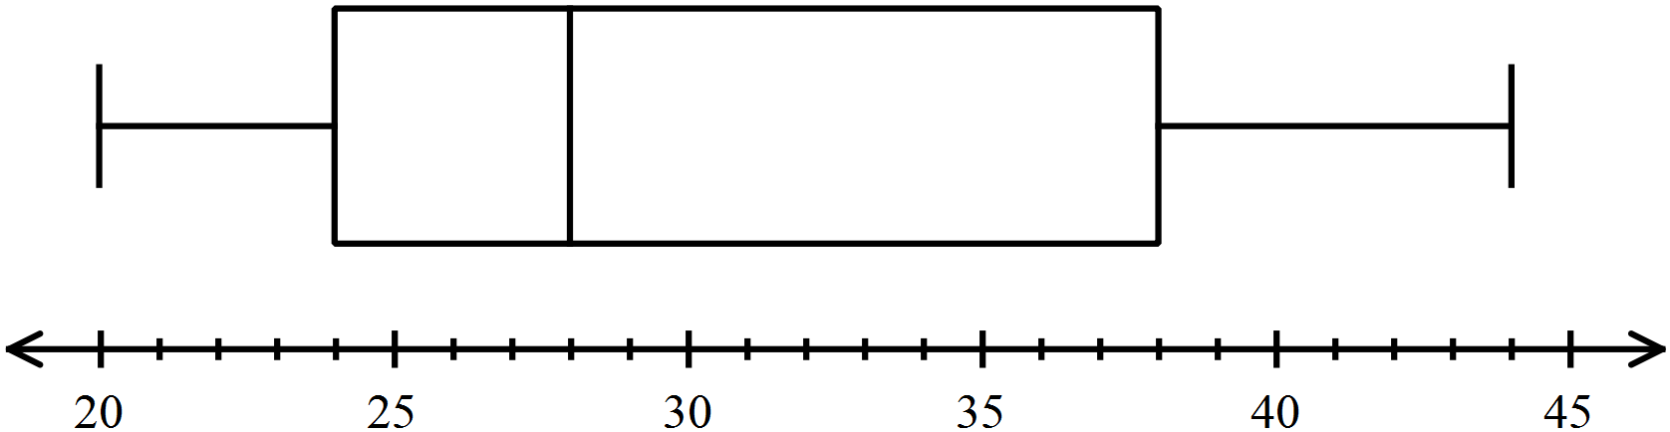  24 is the bottom of the box, so the lower quartile (25% mark).  44 is the top extreme (100% mark)  There are 75% of scores between these. |  |  | D
 | Both have a gradient of 2, so are parallel. |  |  | C
 | It is a concave down parabola, so the equation could be 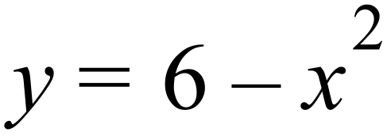 |  |  | C
 | The triangles are similar, one pair of equal angles given, and a pair of vertically opposite angles equal, so triangles are equiangular and hence similar.  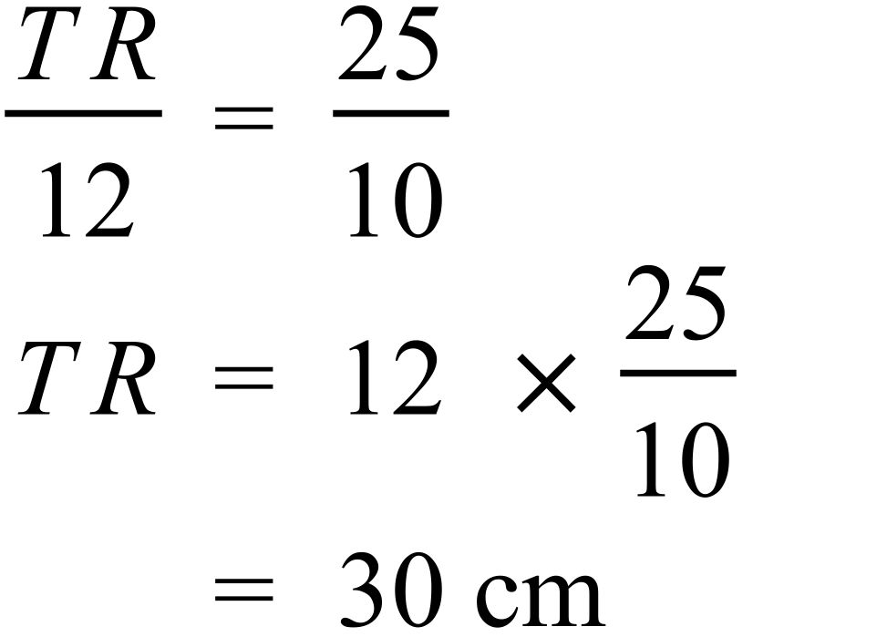 |  |  | B
 | A strong positive relationship indicates the points group around a straight line which has a positive gradient, so A meets this criteria. |  |  | A
 | 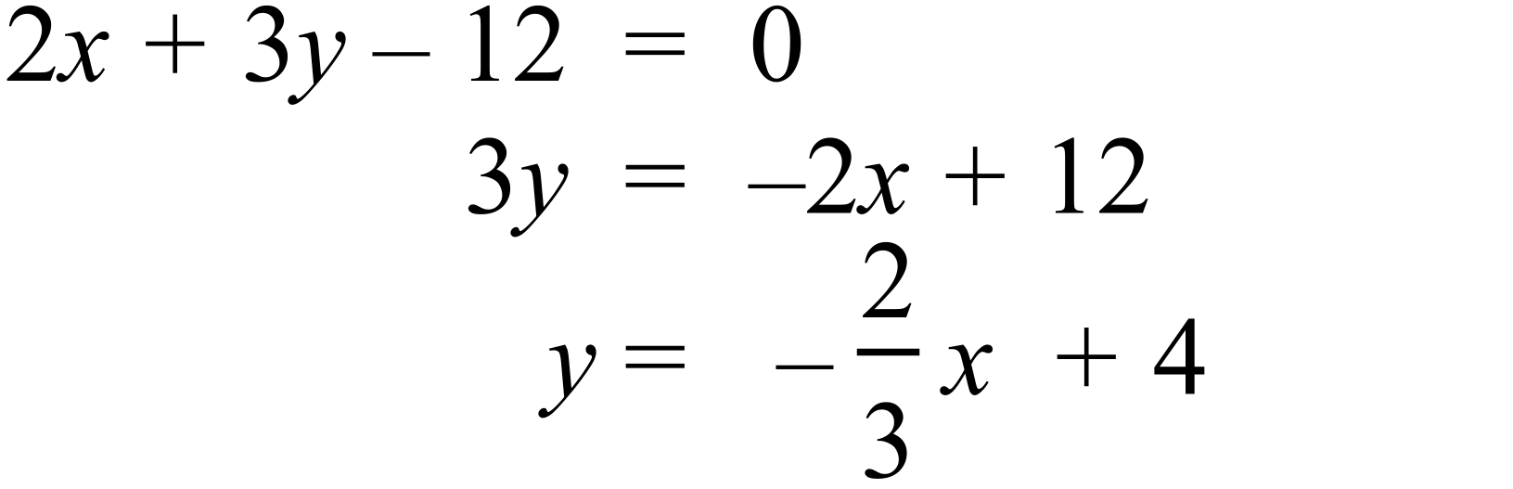  Gradient is 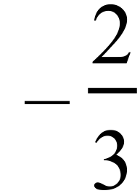  Perpendicular line has gradient 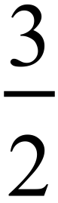 .  Required line 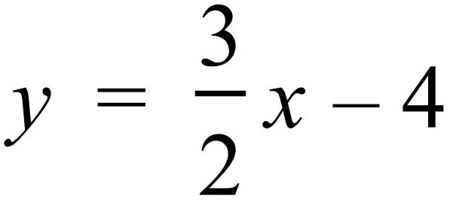 |  |  | D
 | 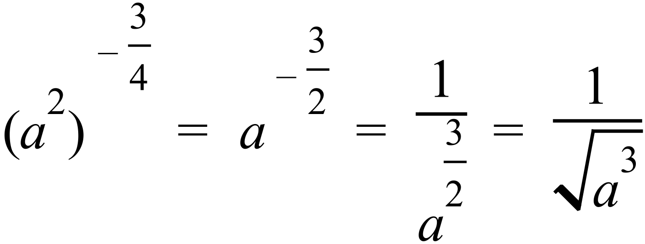 |  |  | B
 | 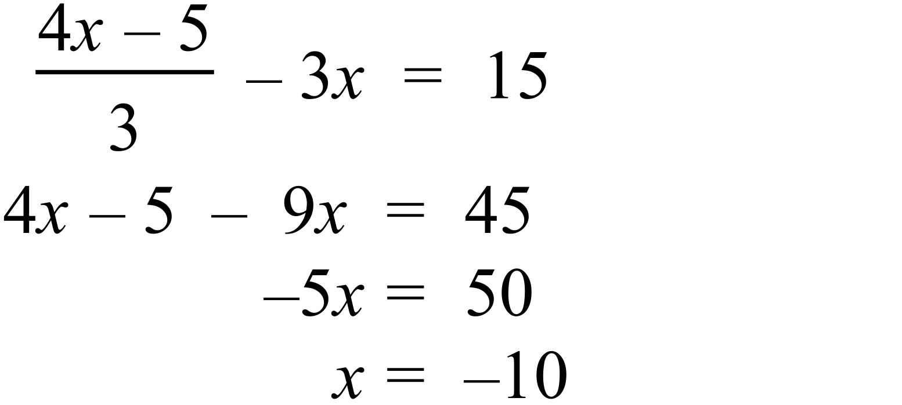 |  |  | A
 | From calculator, correct to 1 dp.  Mean = 8.3 SD = 0.9 |  |  | A
 |  |  |  | C
 | 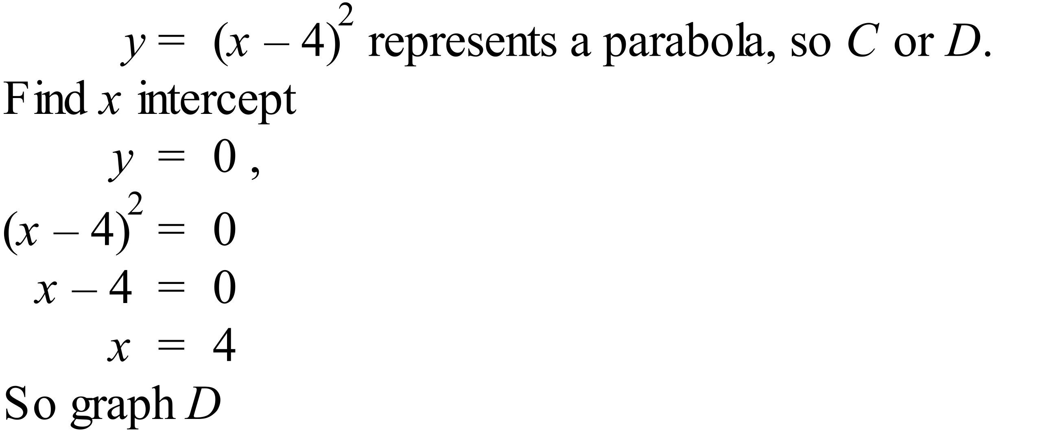 |  |  | D
 | 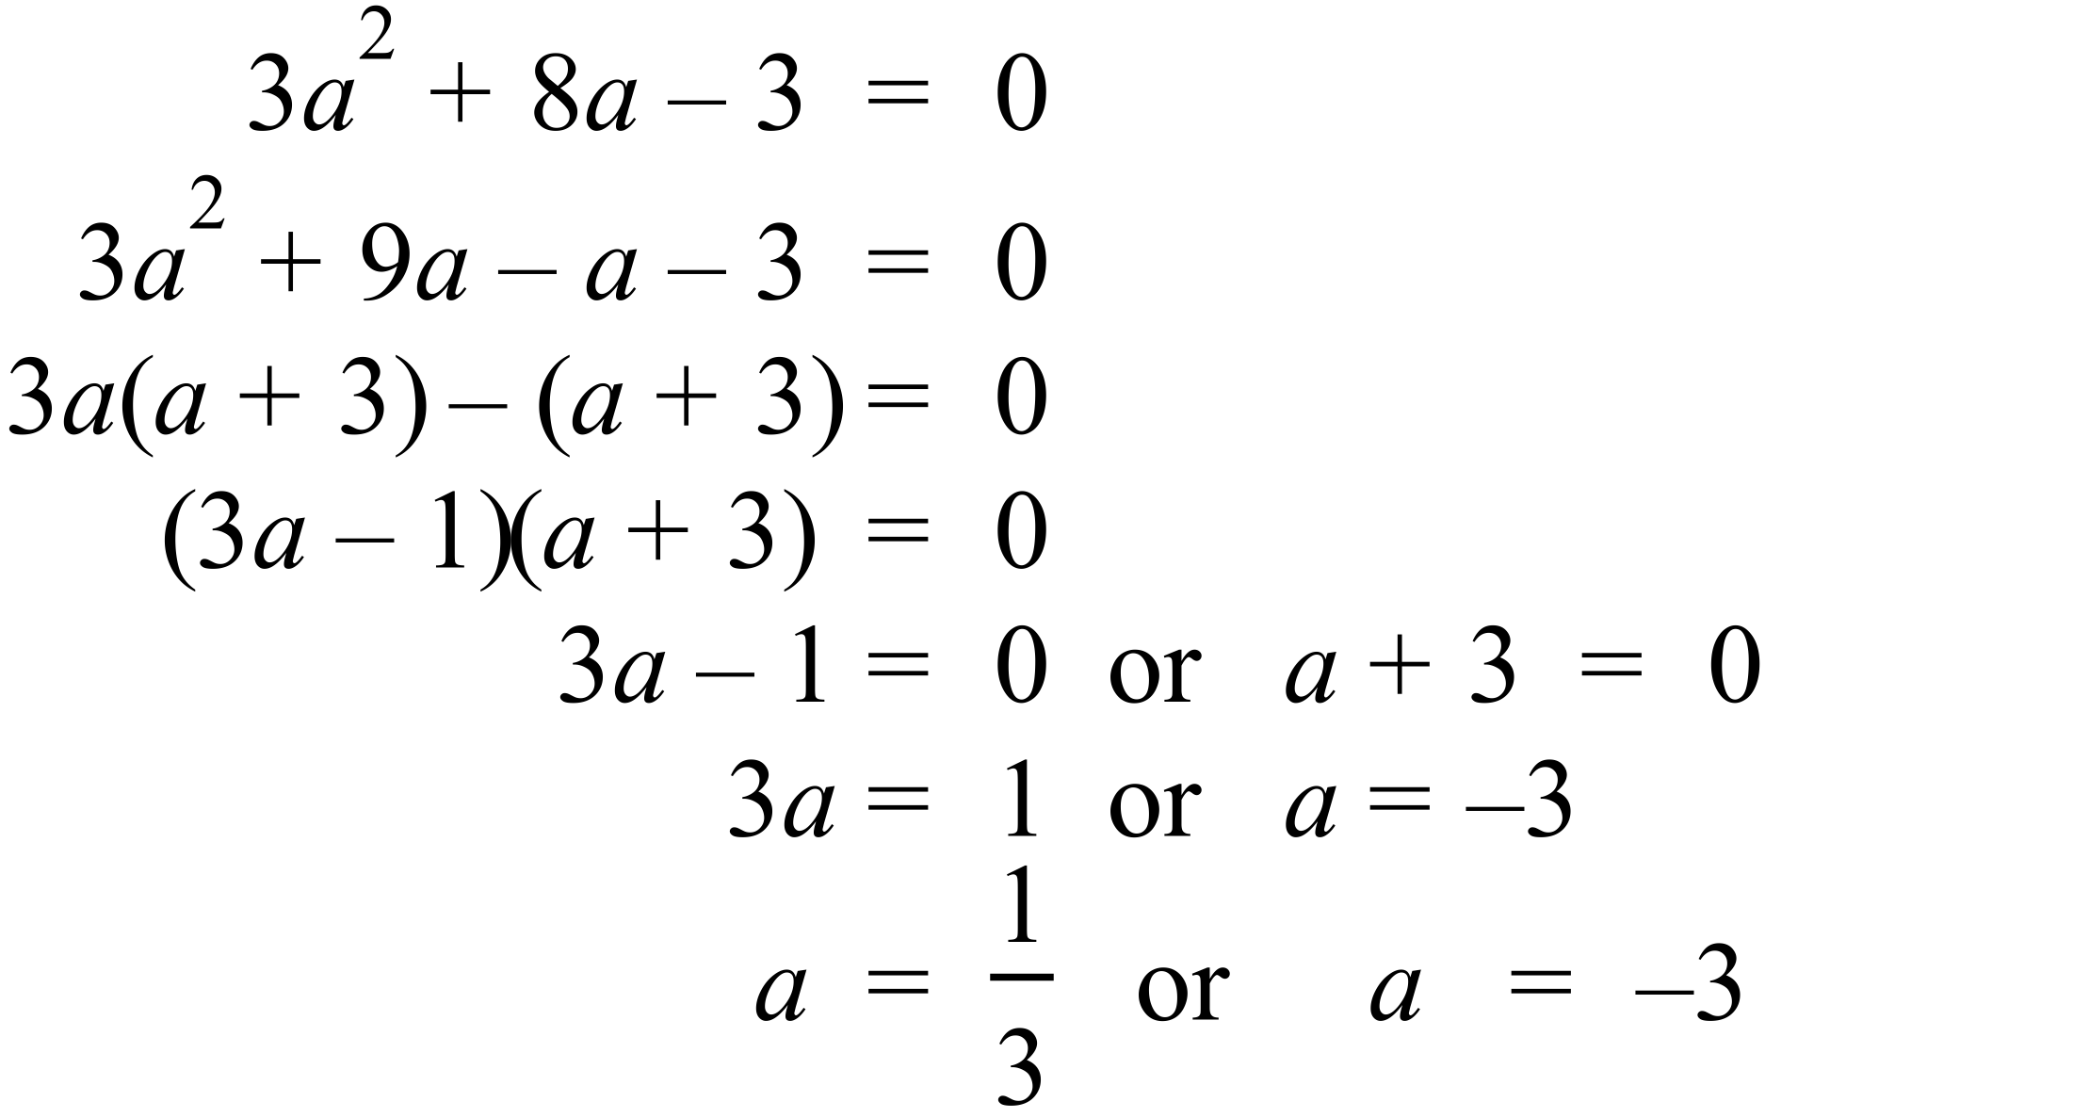 |  |  | B
 | 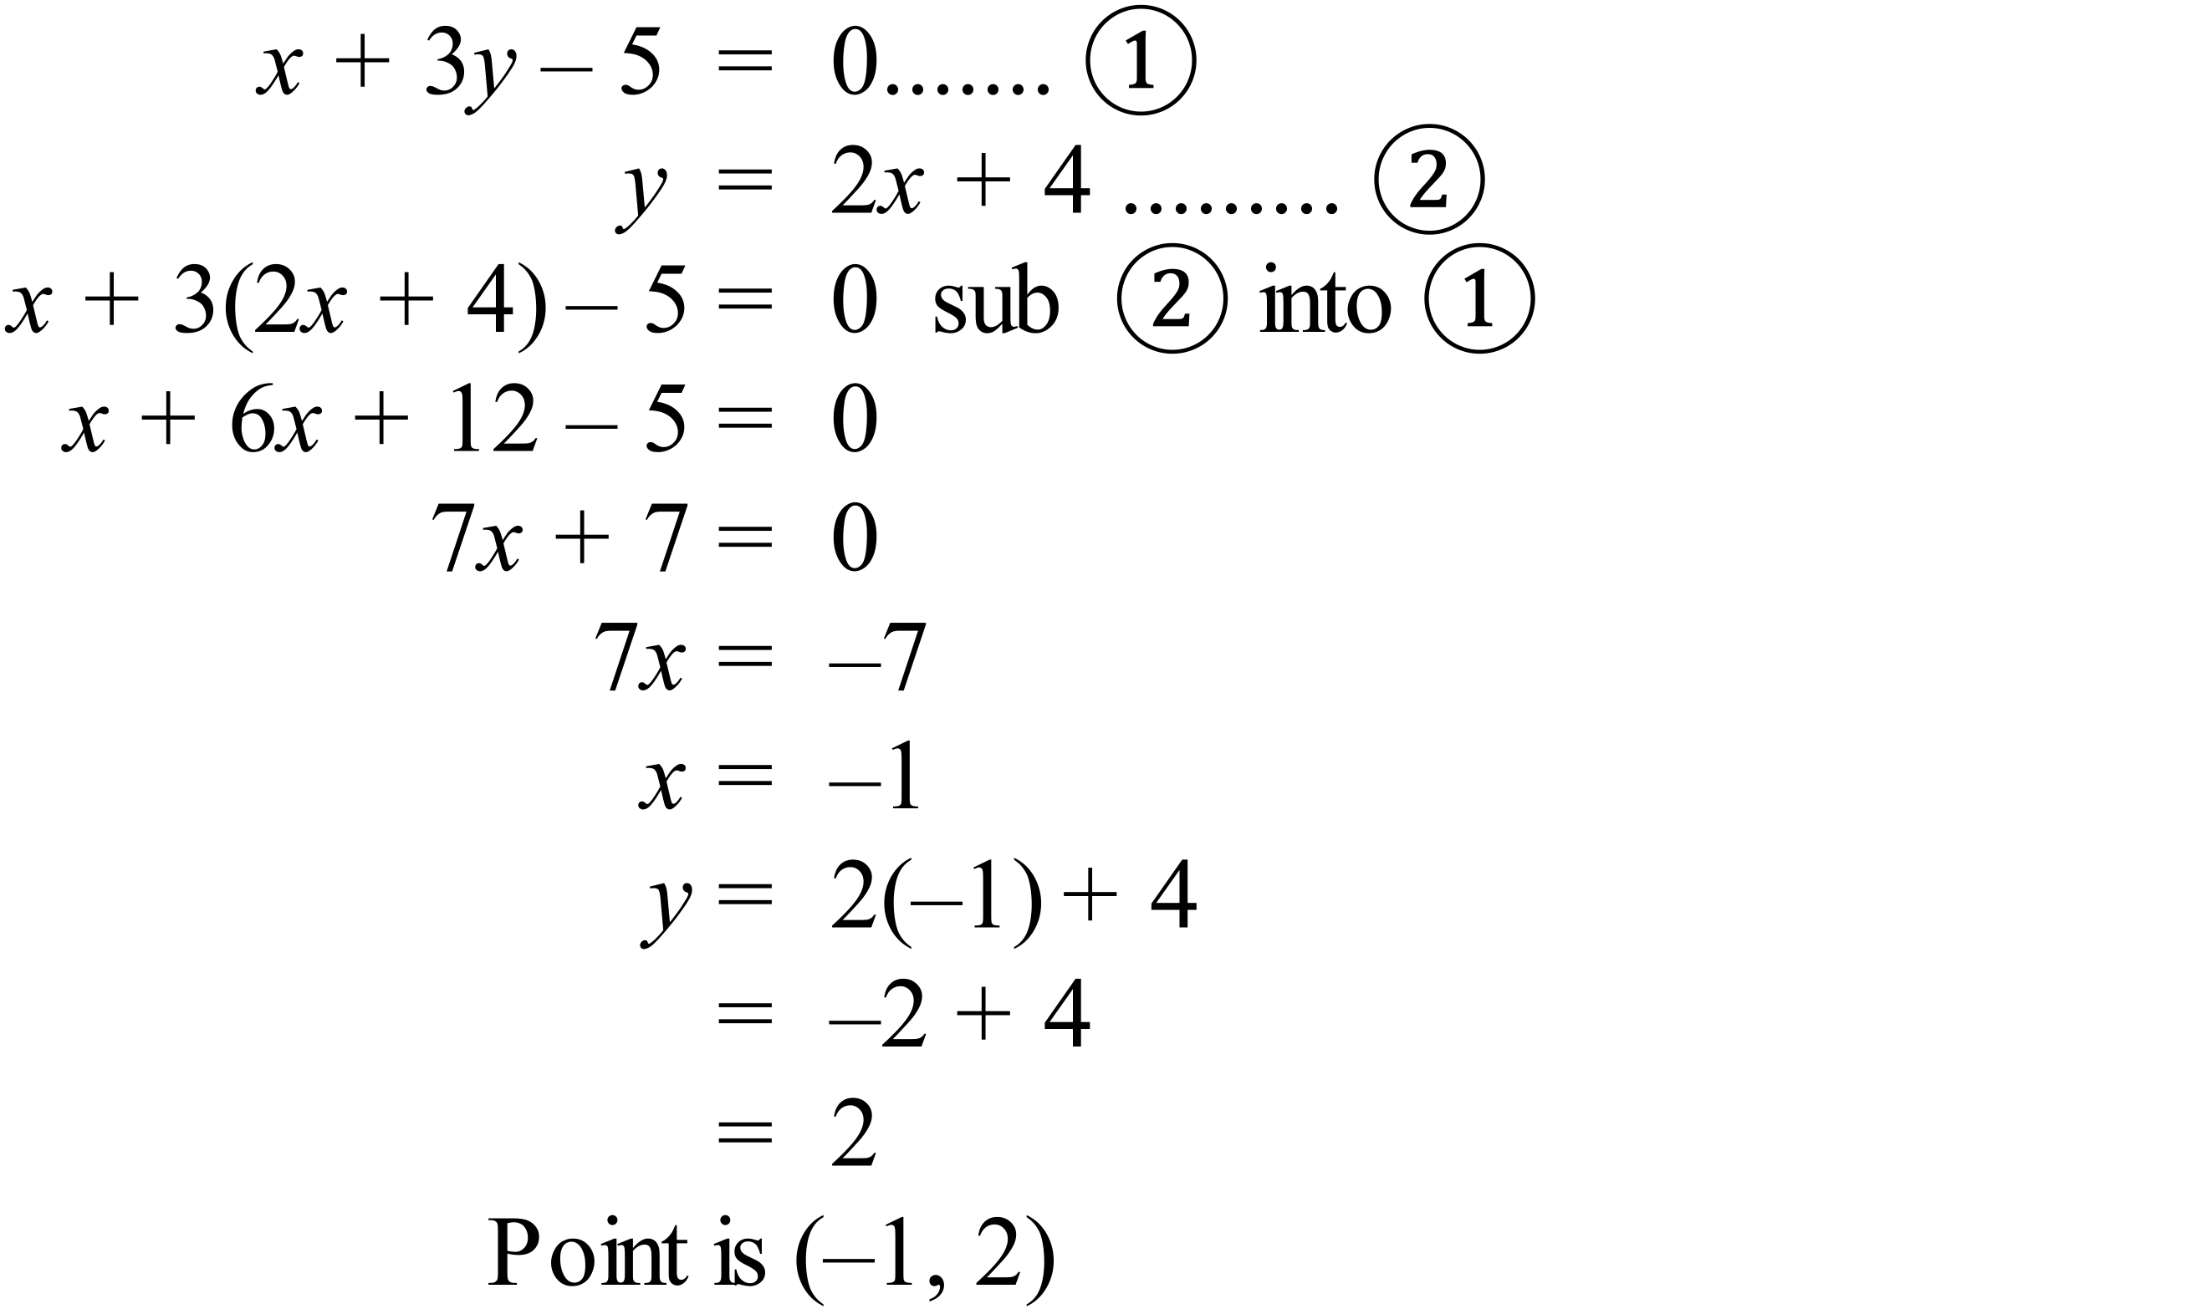 |  |  | B
 | Begins increasing at a decreasing rate due to gradual widening.  Then increases at a constant rate due to constant width.  Then increases at a faster constant rate due to sudden narrowing.  Lastly increases at an increasing rate due to gradual narrowing. |  |  | A
 | 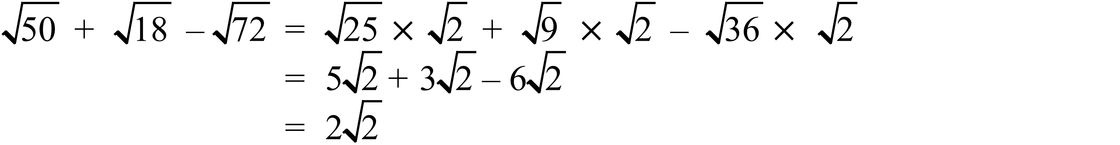 |  |  | C
 | 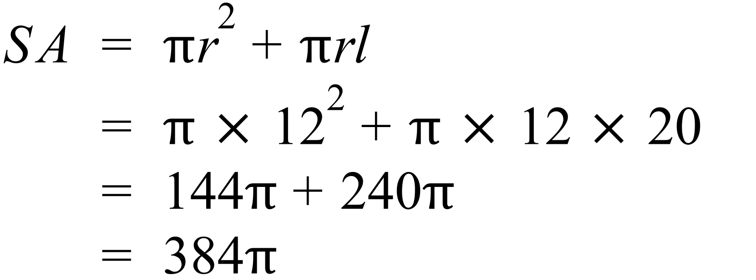 |  |  | C
 | 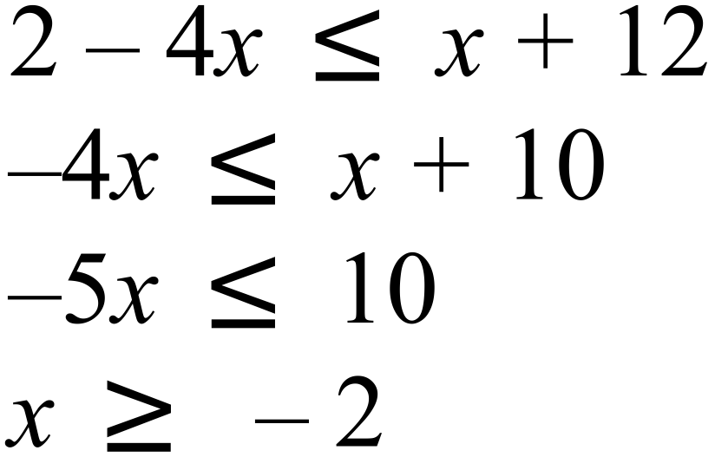 |  |  | D
 |  |  |  | A
 | 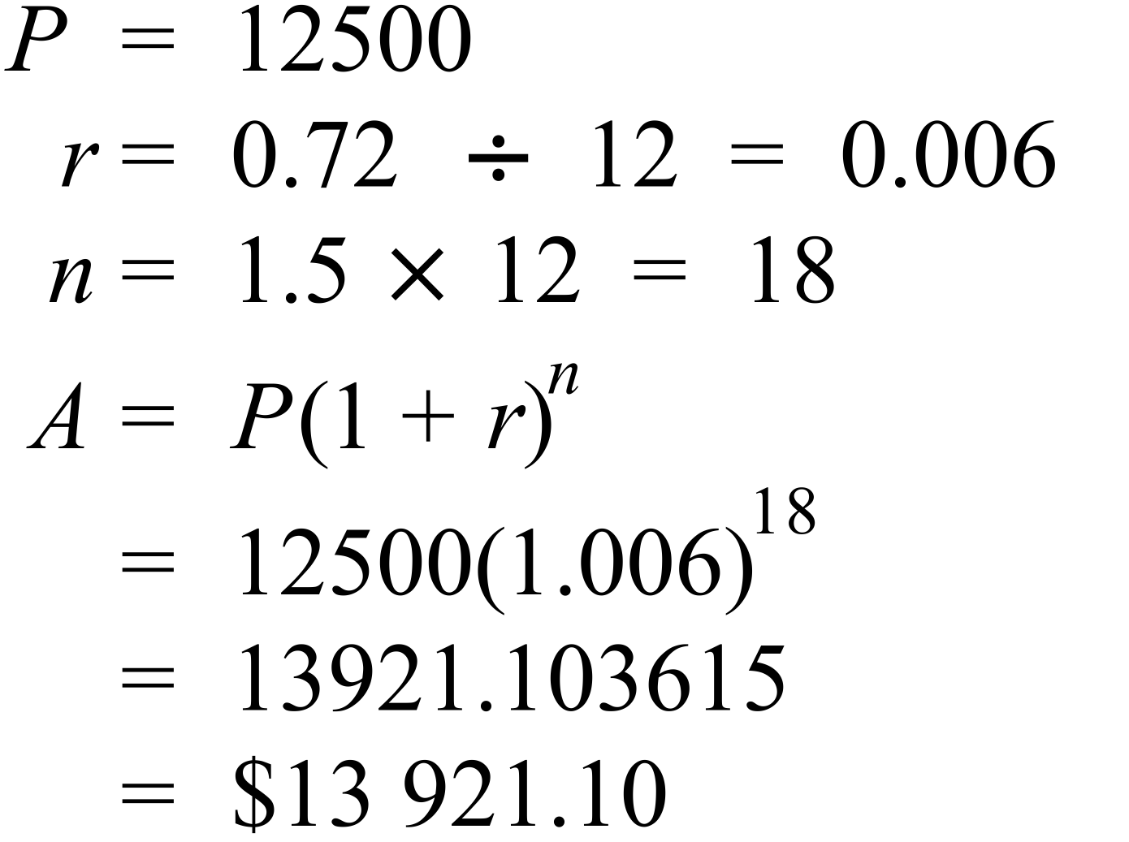 |  |  | C
 | 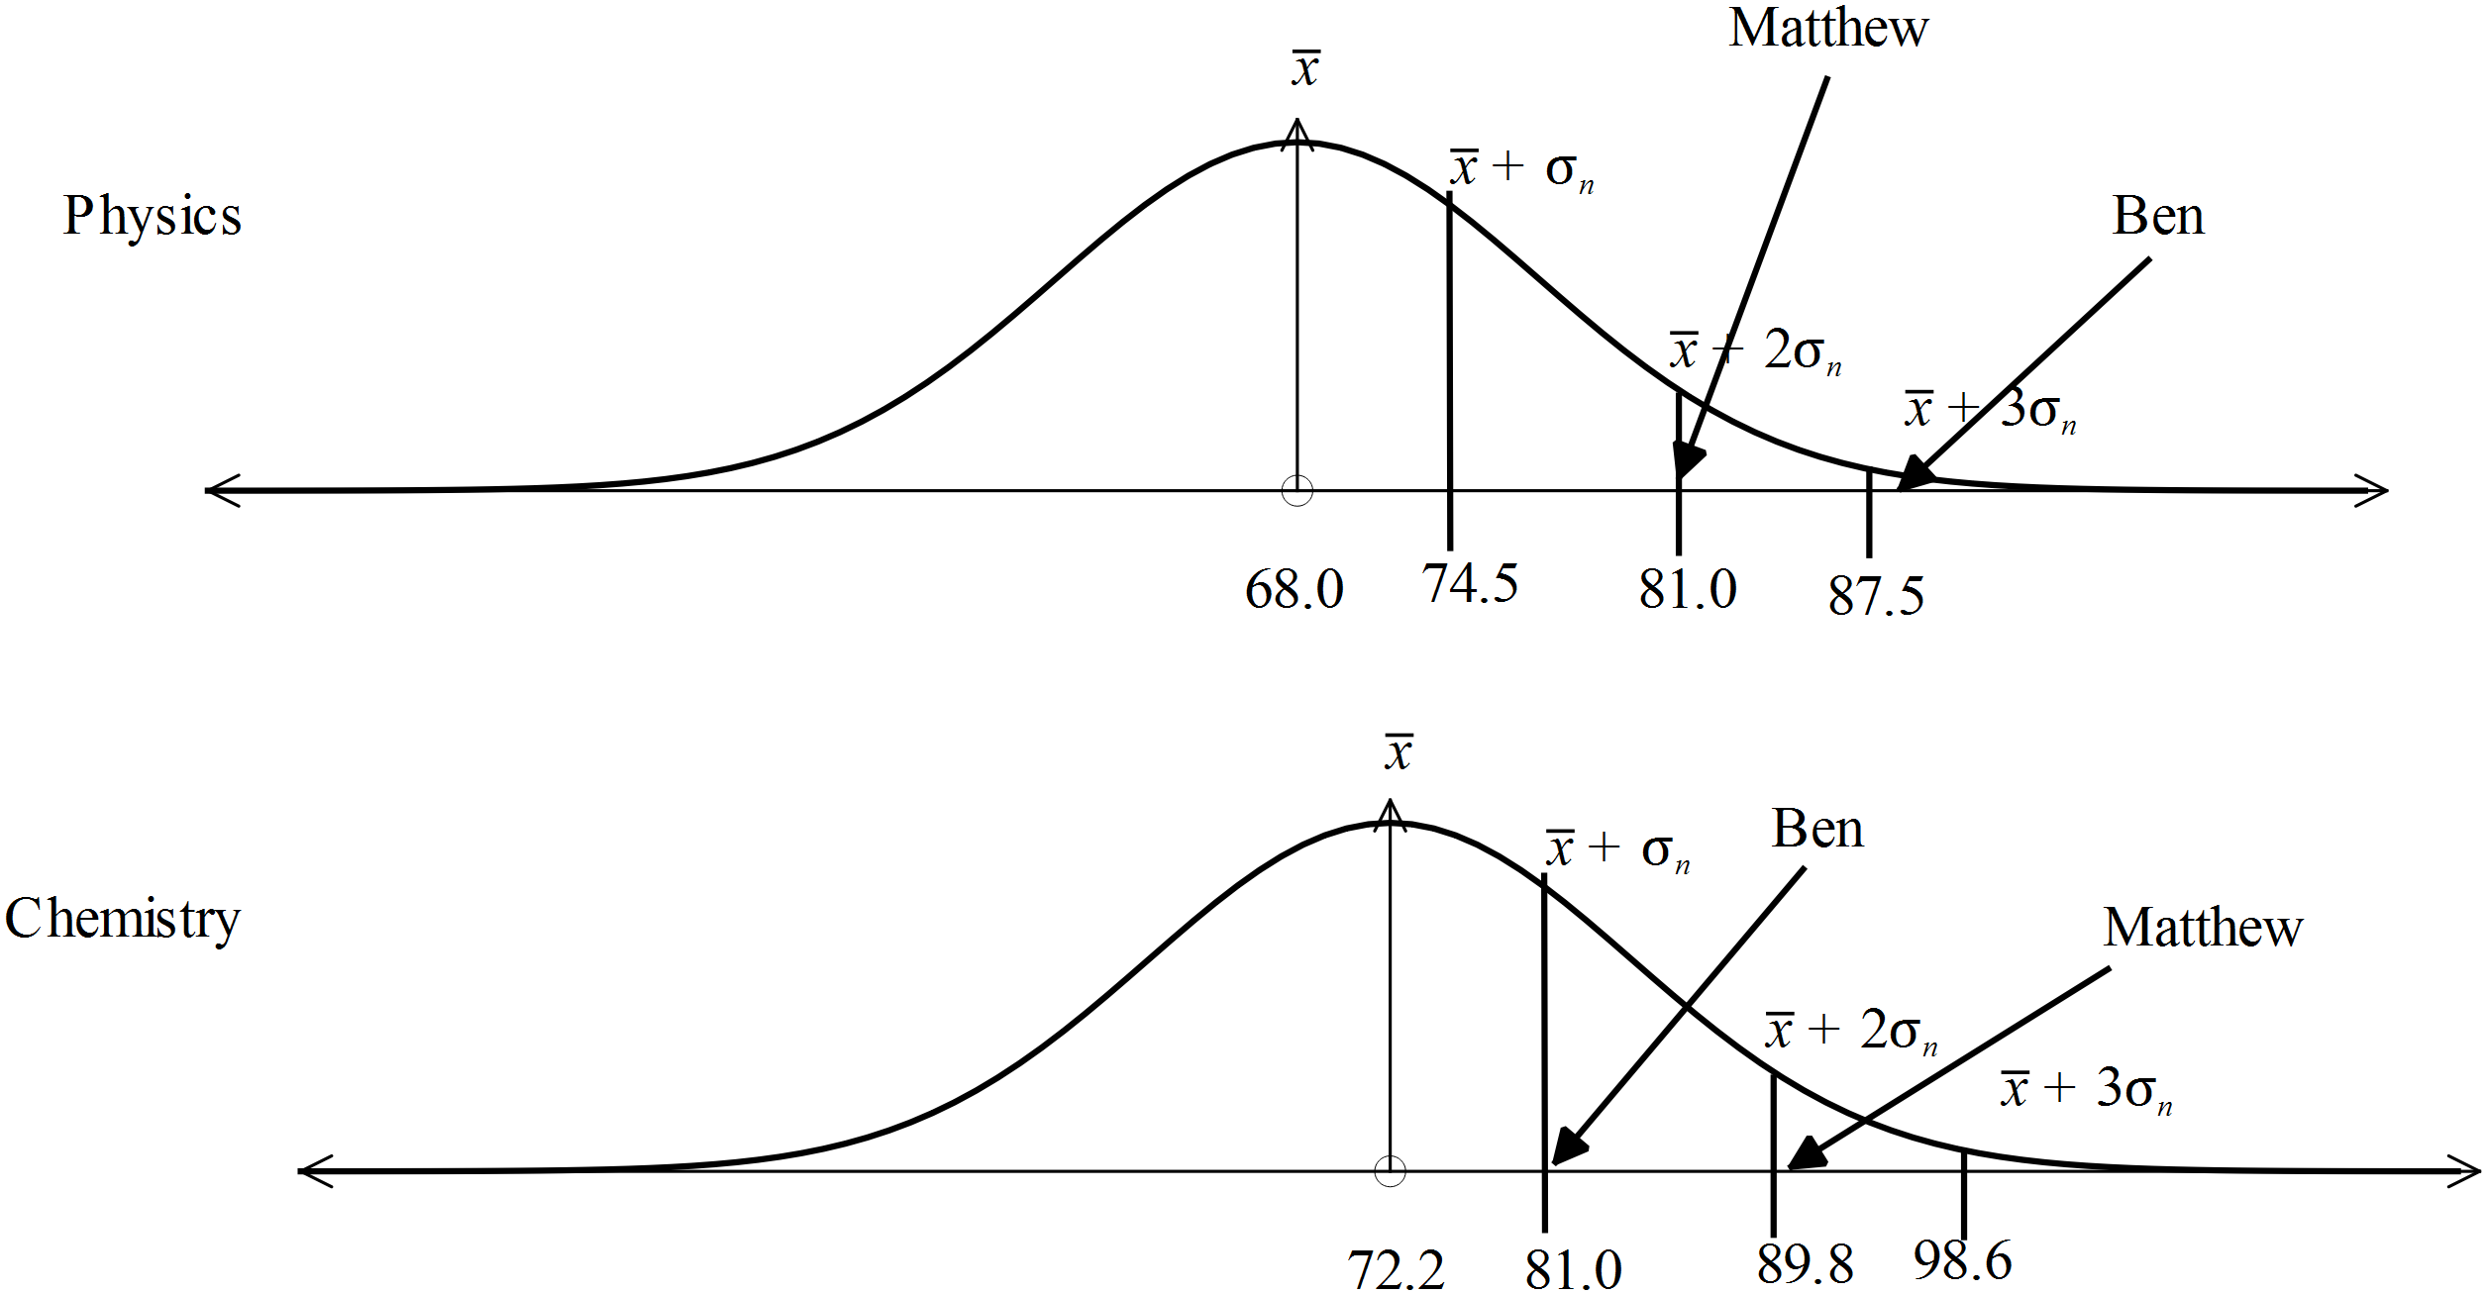  Ben’s Physics mark is over 3 SD above the mean, where the best of the others is just over 2 SD above the mean, so it is the best in comparison. |  |  | B
 | 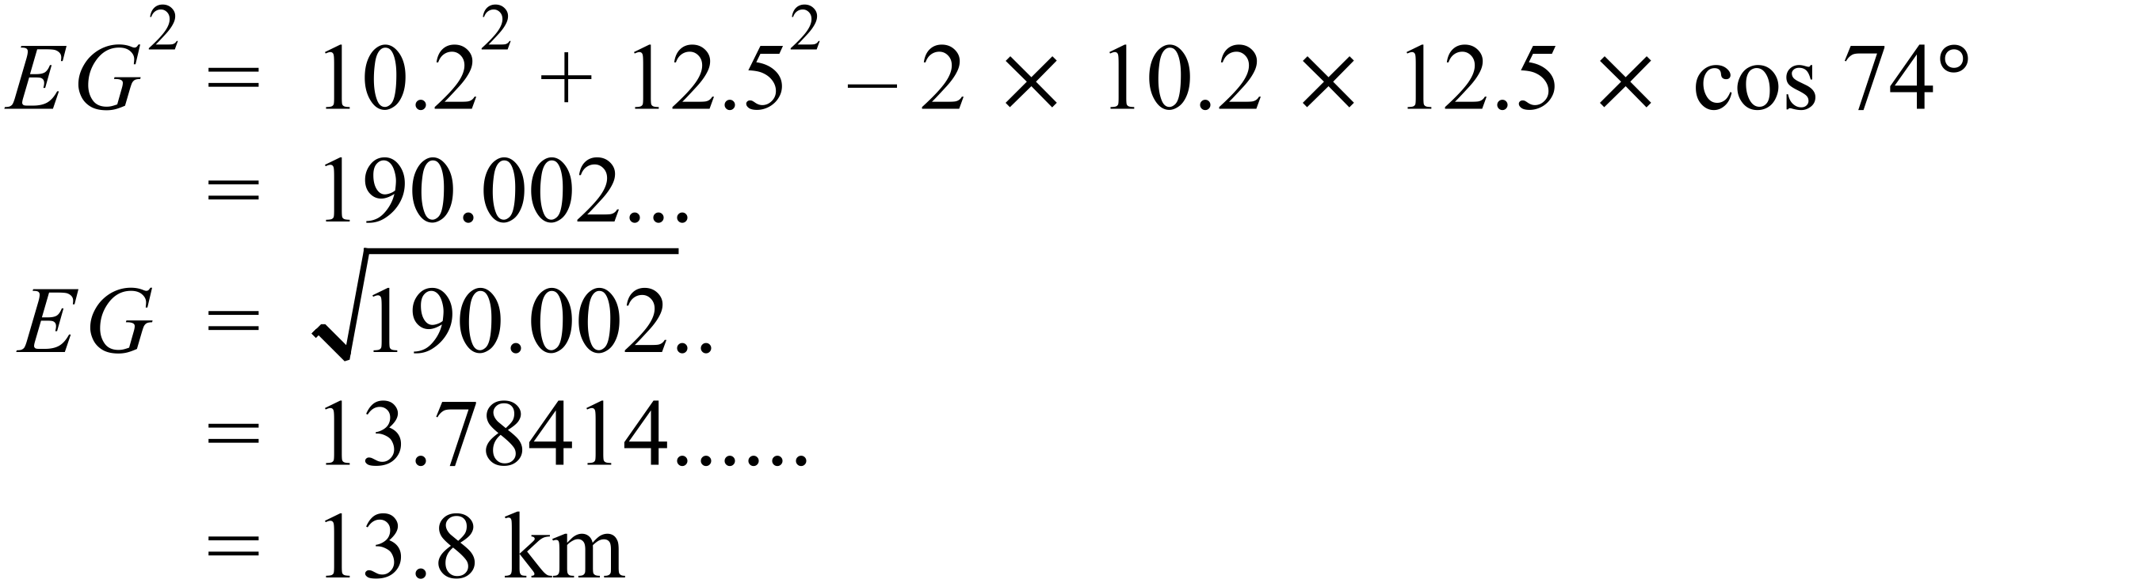 |  |  | B
 | 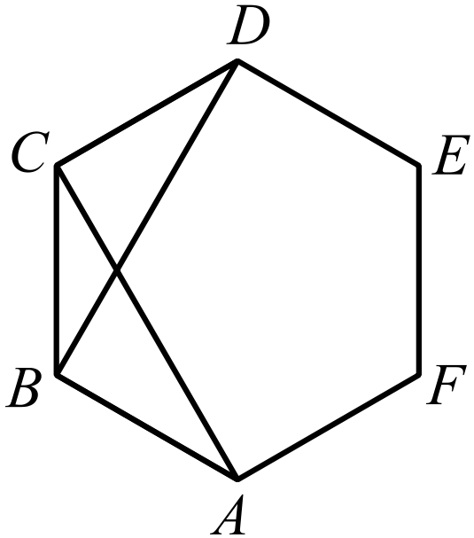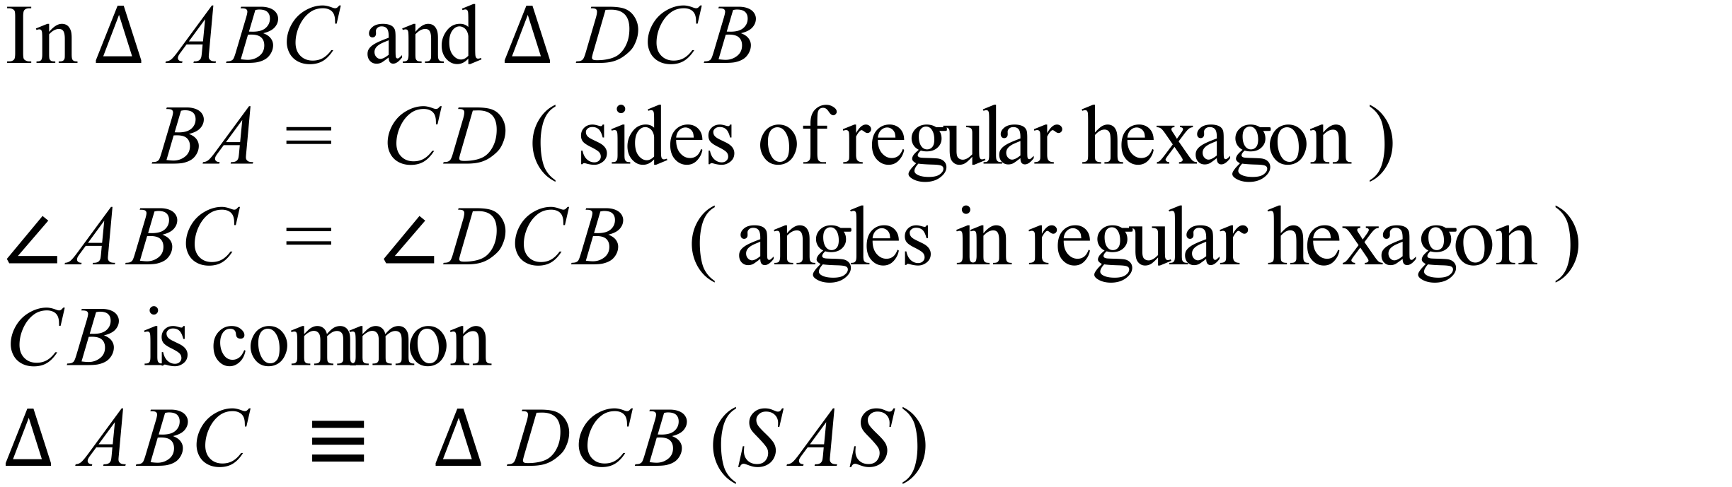 |  |  | C
 | There are 8 colours on each, so there are 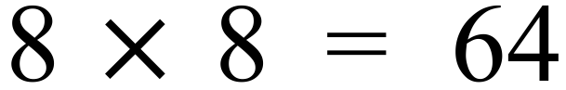 pairs of colours possible. |  |  | C
 | Line with gradient of 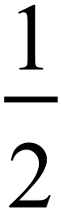 through the point (12, 5).  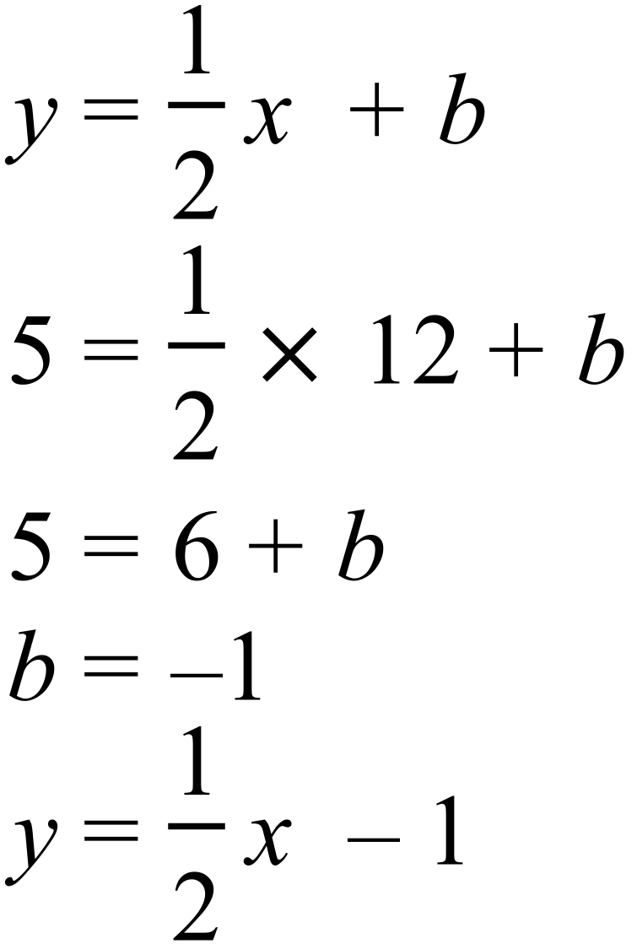 |  |  | A
 | 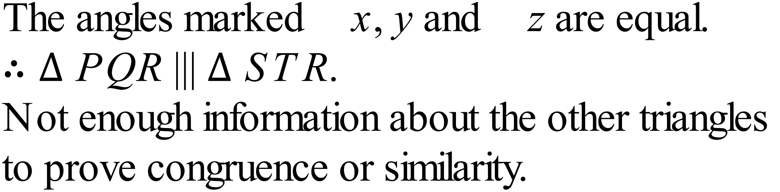  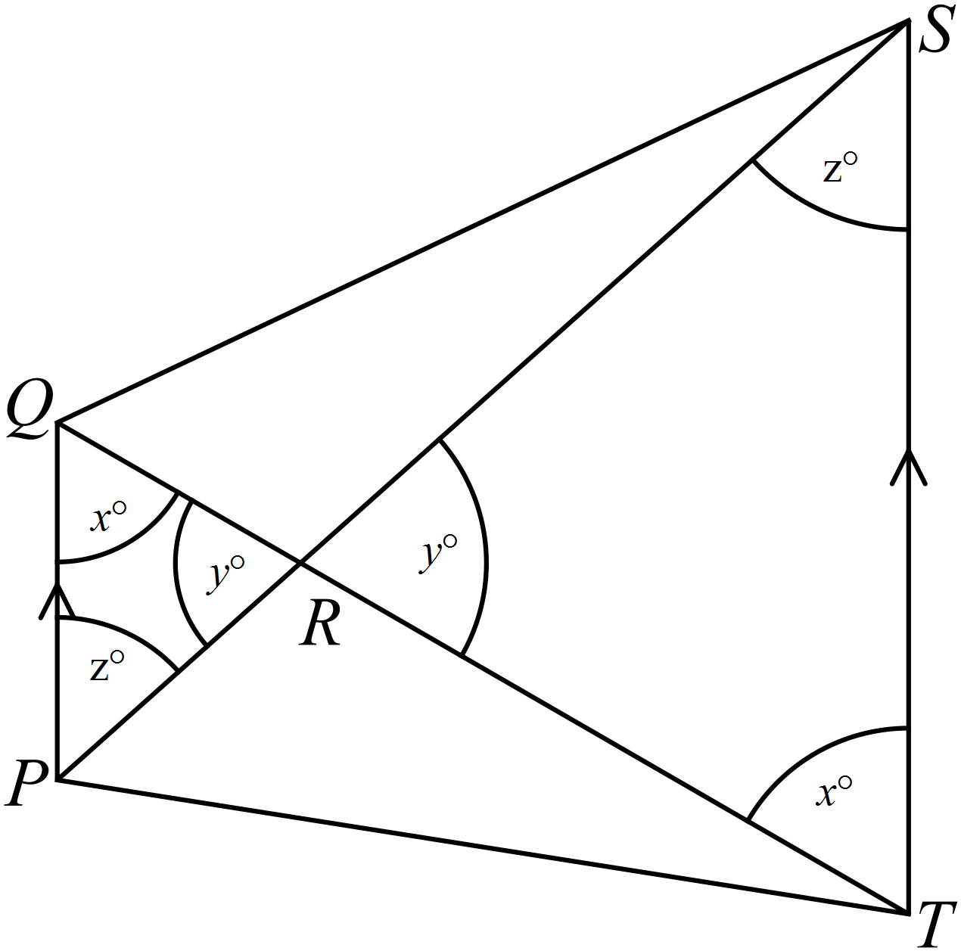 |  |  | A
 | 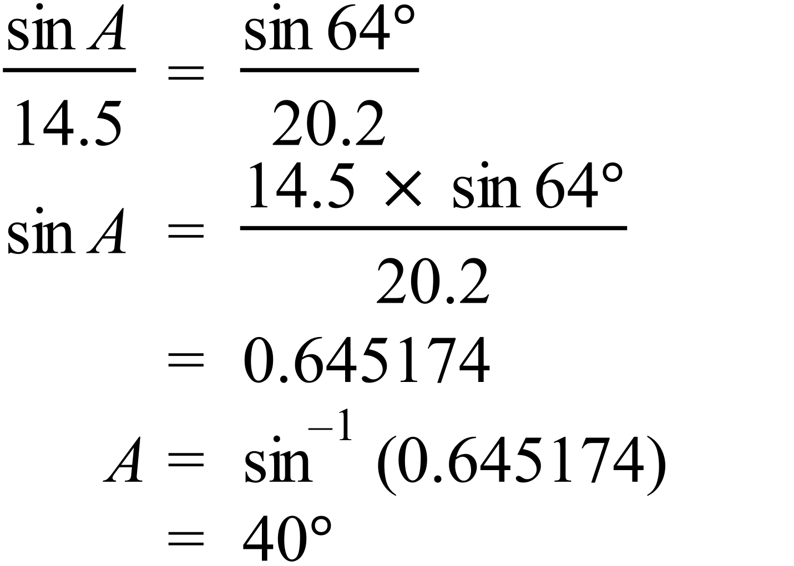 |  |  | D
 | 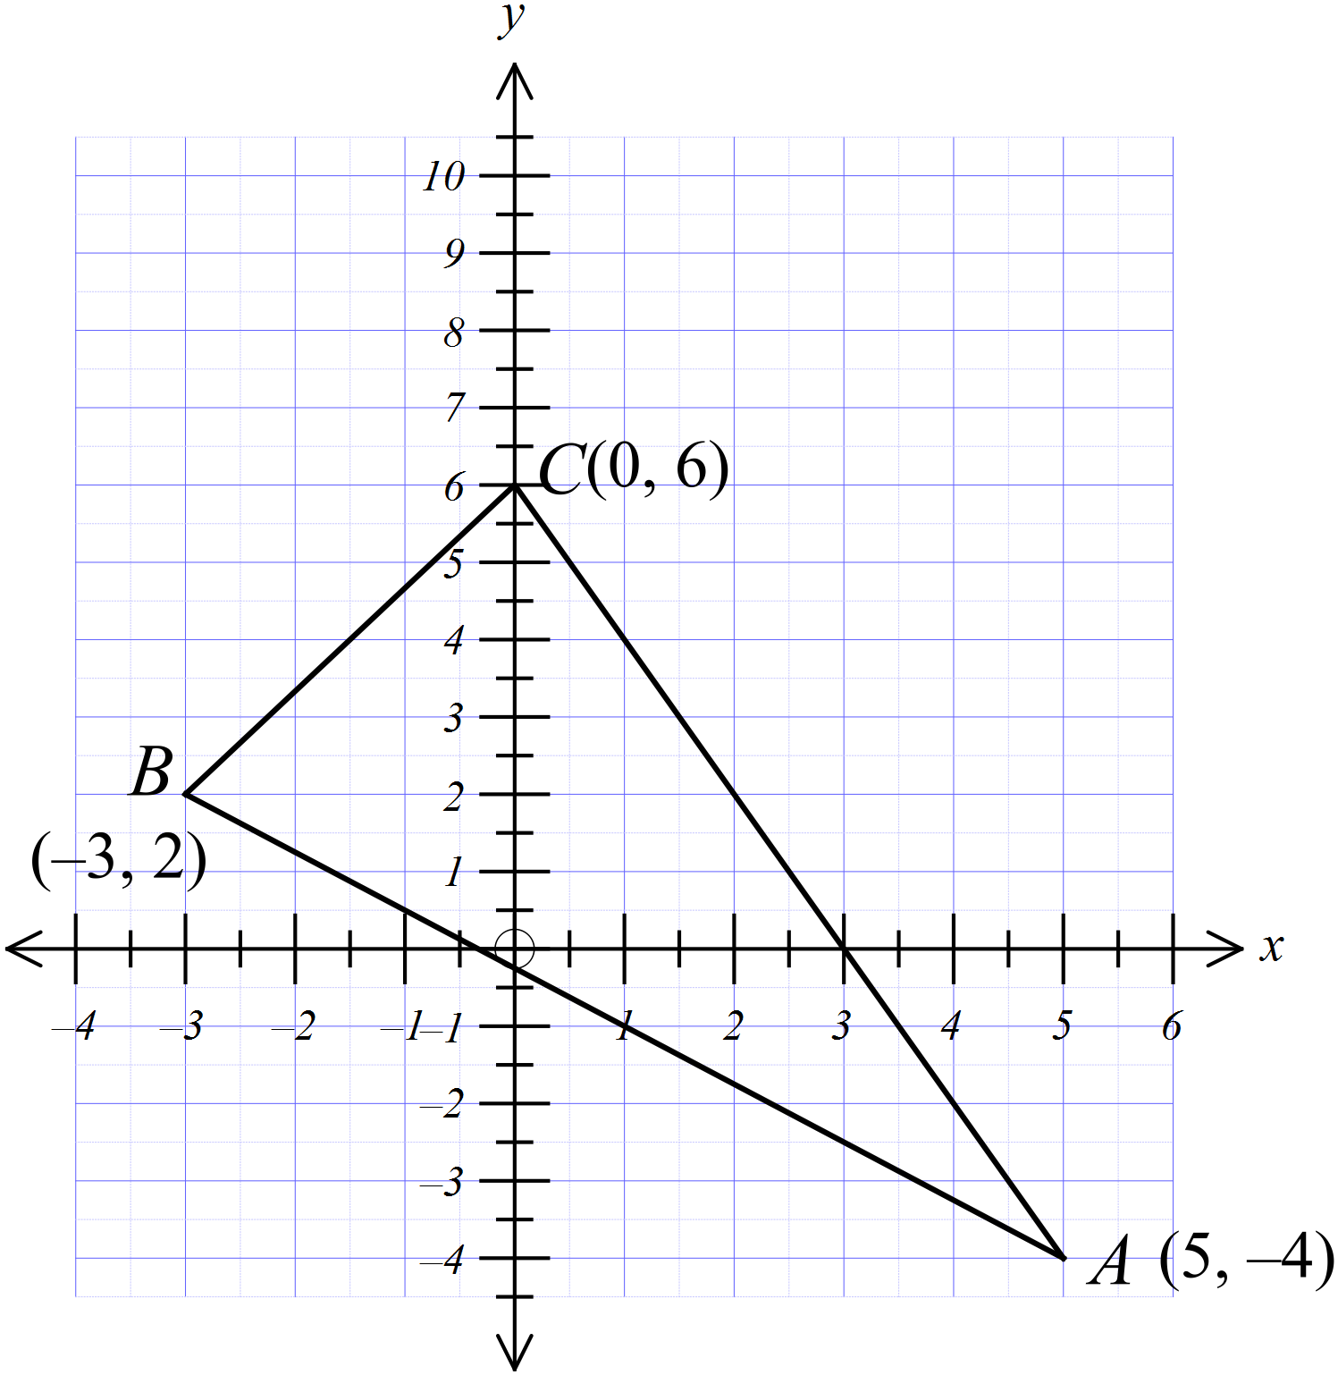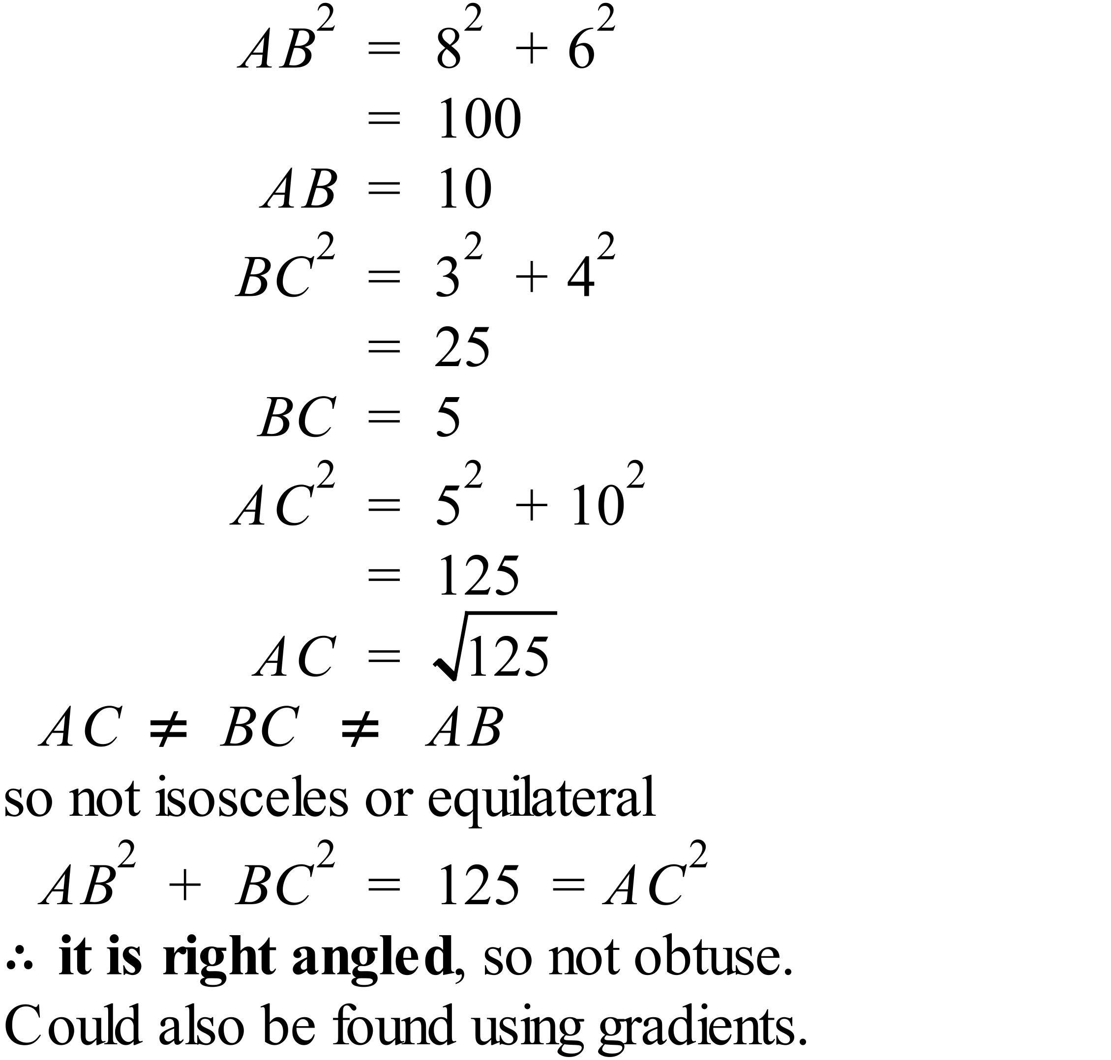 |  |  | D
 | 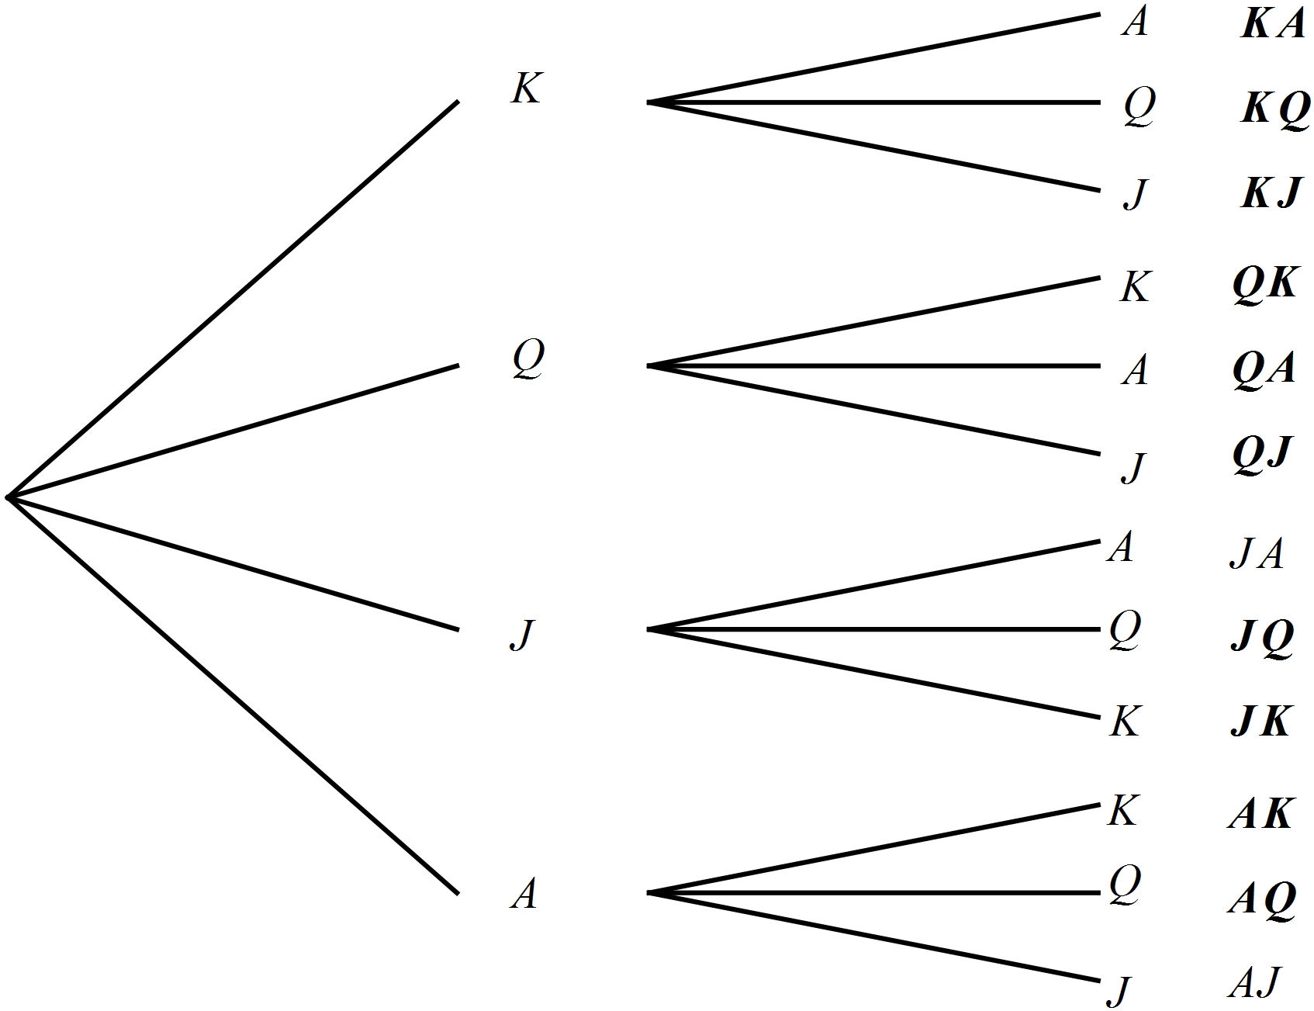  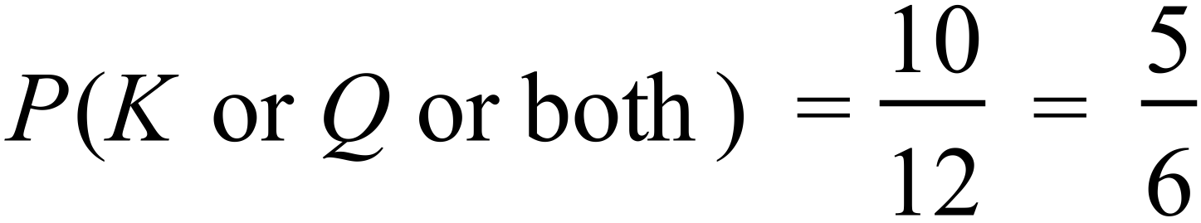 |  |  | C
 | 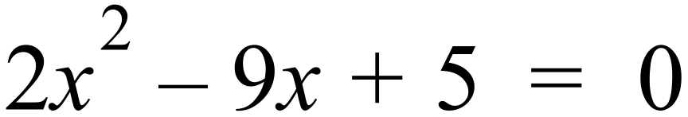  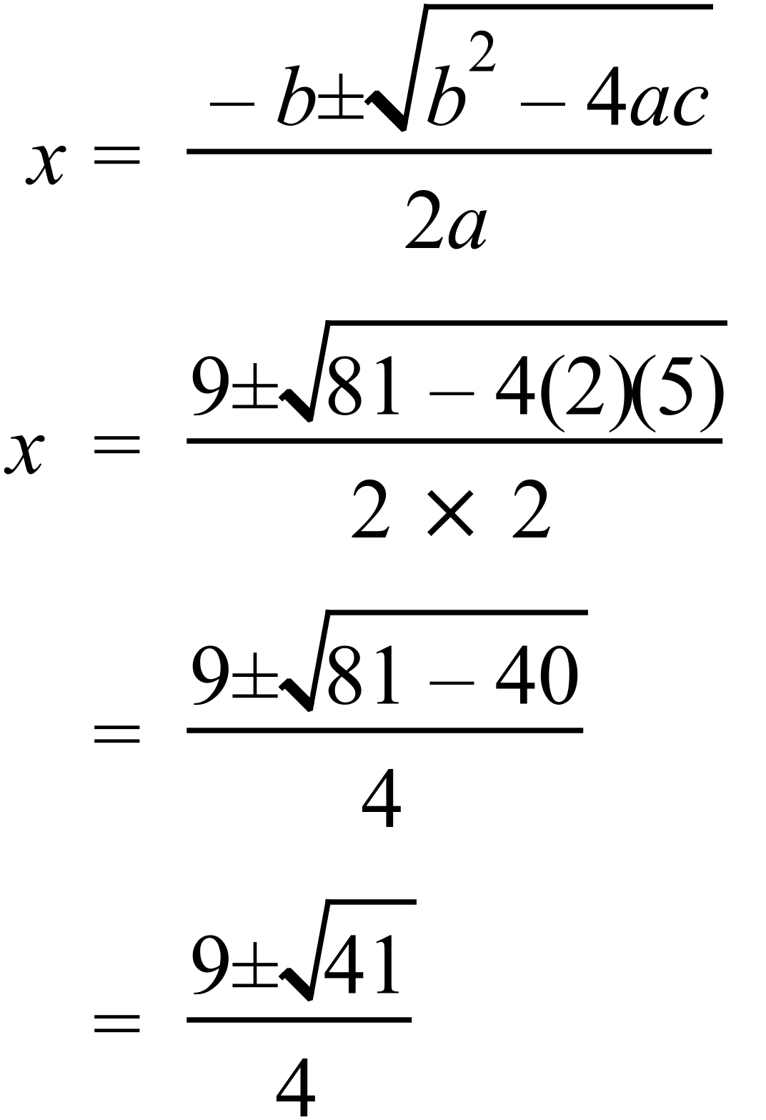 |  |  | B
 | The graph is an exponential so the equation could be 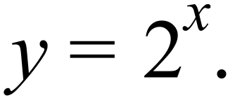 |  |  | D

School Name
Year 10 Yearly Examination
WME Yearly Advanced Maths Course 2015
Multiple Choice Section Answer Sheet
Name ________________________________ Teacher ________________________

Completely fill the response oval representing the most correct answer.
Use a black or blue pen or 2B pencil.

26. A B C D
27. A B C D
28. A B C D
29. A B C D
30. A B C D
31. A B C D
32. A B C D
33. A B C D
34. A B C D
35. A B C D
36. A B C D
37. A B C D
38. A B C D
39. A B C D
40. A B C D
41. A B C D
42. A B C D
43. A B C D
44. A B C D
45. A B C D
46. A B C D
47. A B C D
48. A B C D
49. A B C D
50. A B C D

51. A B C D
52. A B C D
53. A B C D
54. A B C D
55. A B C D
56. A B C D
57. A B C D
58. A B C D
59. A B C D
60. A B C D
61. A B C D
62. A B C D
63. A B C D
64. A B C D
65. A B C D
66. A B C D
67. A B C D
68. A B C D
69. A B C D
70. A B C D
71. A B C D
72. A B C D
73. A B C D
74. A B C D
75. A B C D

Year 10 |  | WME Yearly Advanced Maths | Calculator Allowed
Section 2 Part B Longer Answer Section
ANSWERS
 |  |  |  | Marks
76. | - The data is positively skewed. |  |  | 1 mark for correct answer
 | - 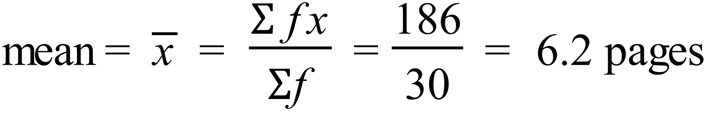  Or using Stats function on calculator. |  |  | 1 mark for correct answer
 | - Interquartile range = 8.75 – 3.00 = 5.75  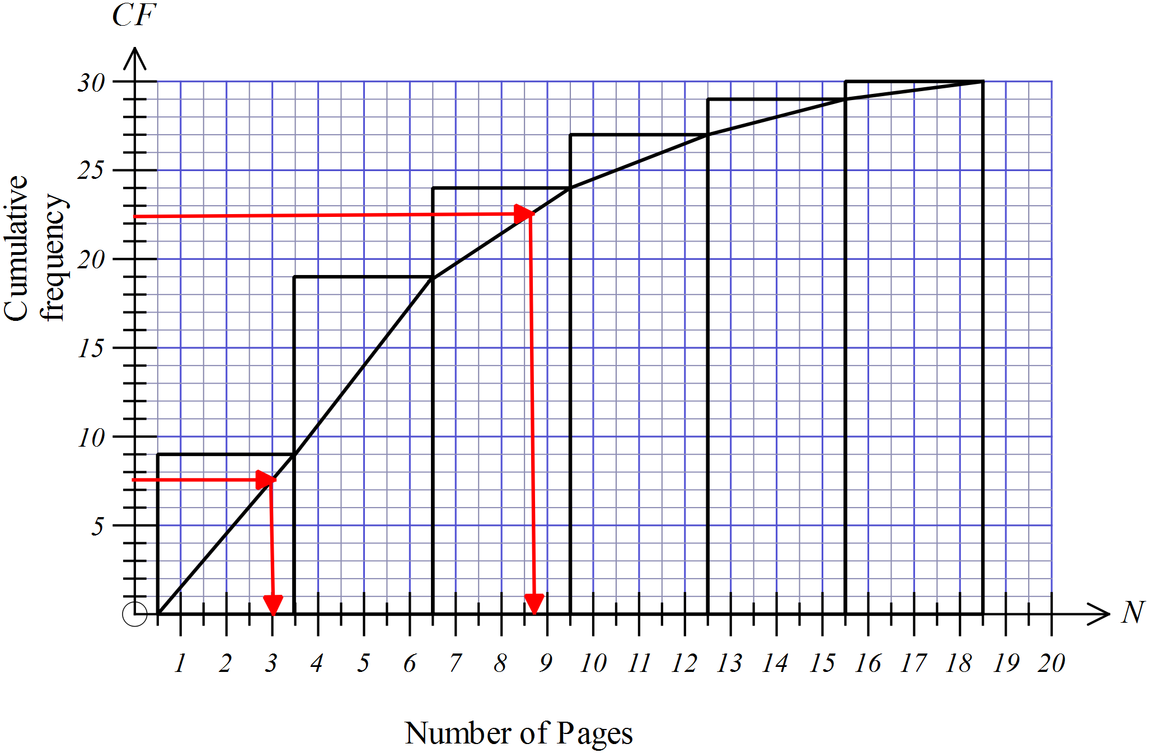 |  |  | 1 mark for correct answer  Allow within 0.25 of the upper and lower quartiles and hence error in the consequent answer.
 | - Standard deviation = 4.07 ( to 2 decimal places)  From Stats function on calculator. |  |  | 1 mark for correct answer
77. | (a)  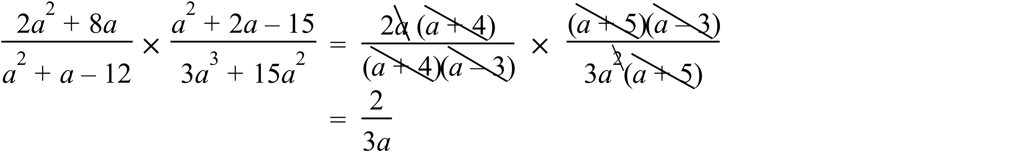 |  |  | 2 marks for correct answer  1 mark for answer with working that shows some correct factorisations and simplifications.
 | (b)  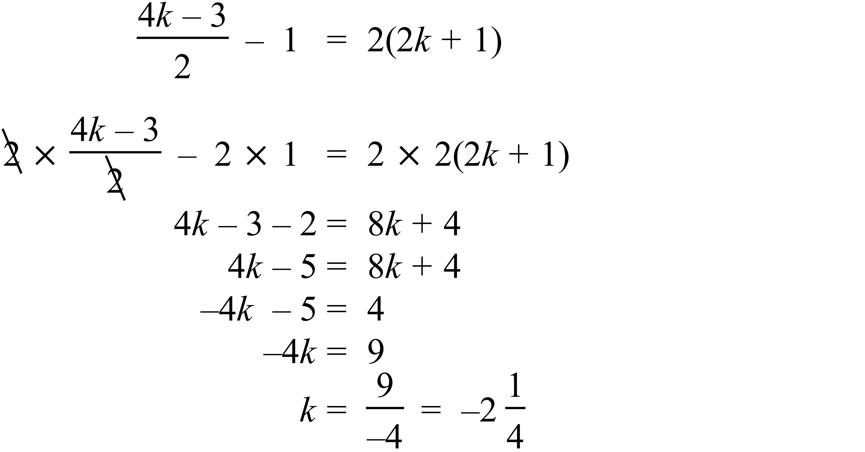 |  |  | 2 marks for correct answer  1 mark for answer with working that shows some correct algebraic manipulation toward answer
78. | 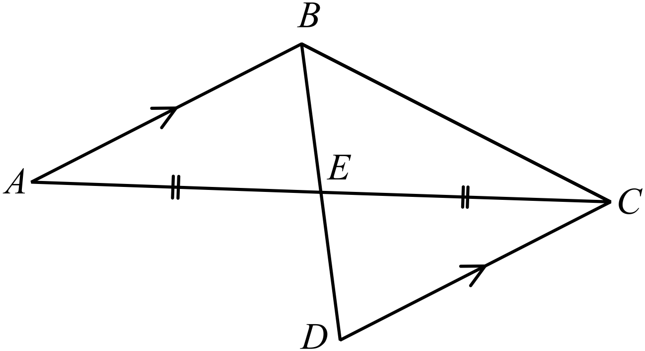  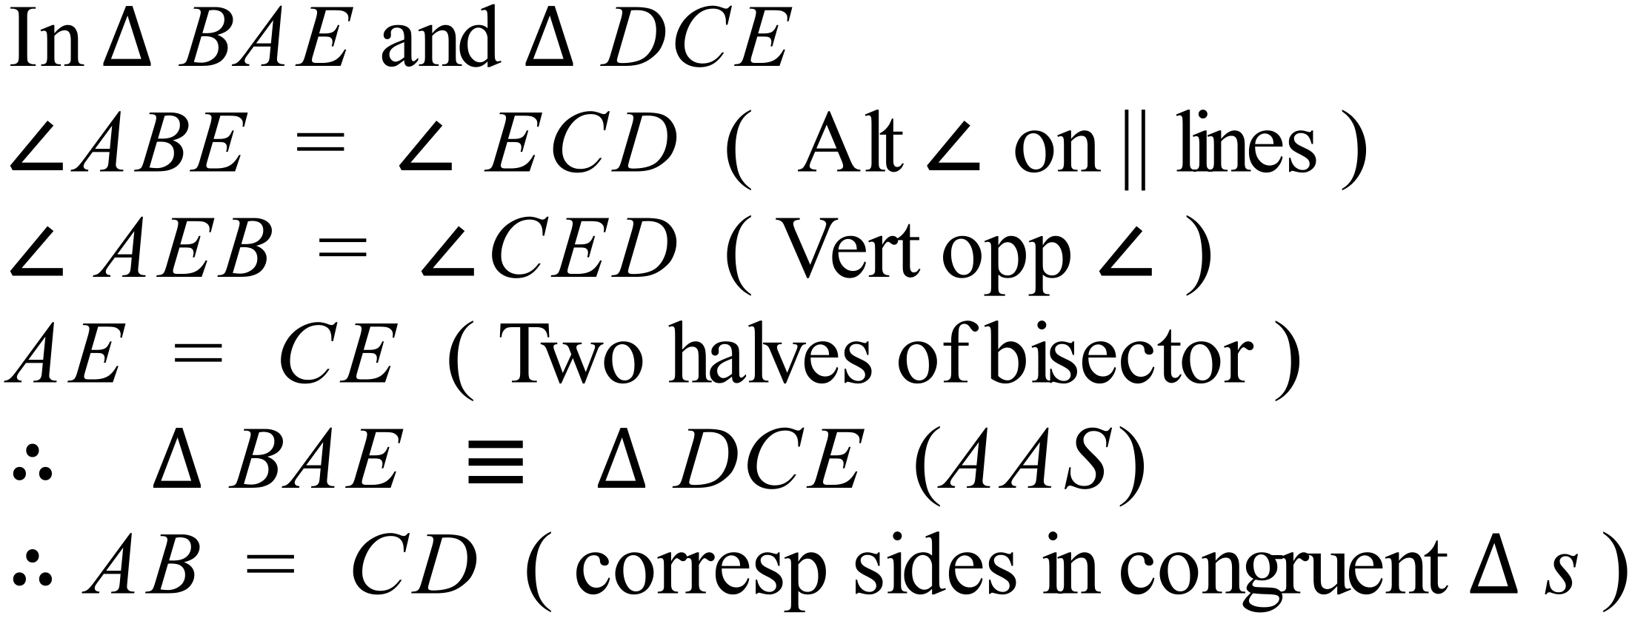 |  |  | 2 marks for a complete proof that includes all necessary steps and reasons where required.  1 mark for a proof that is incomplete, or has a minor error in reasoning or has reasons missing.
79. | (a)  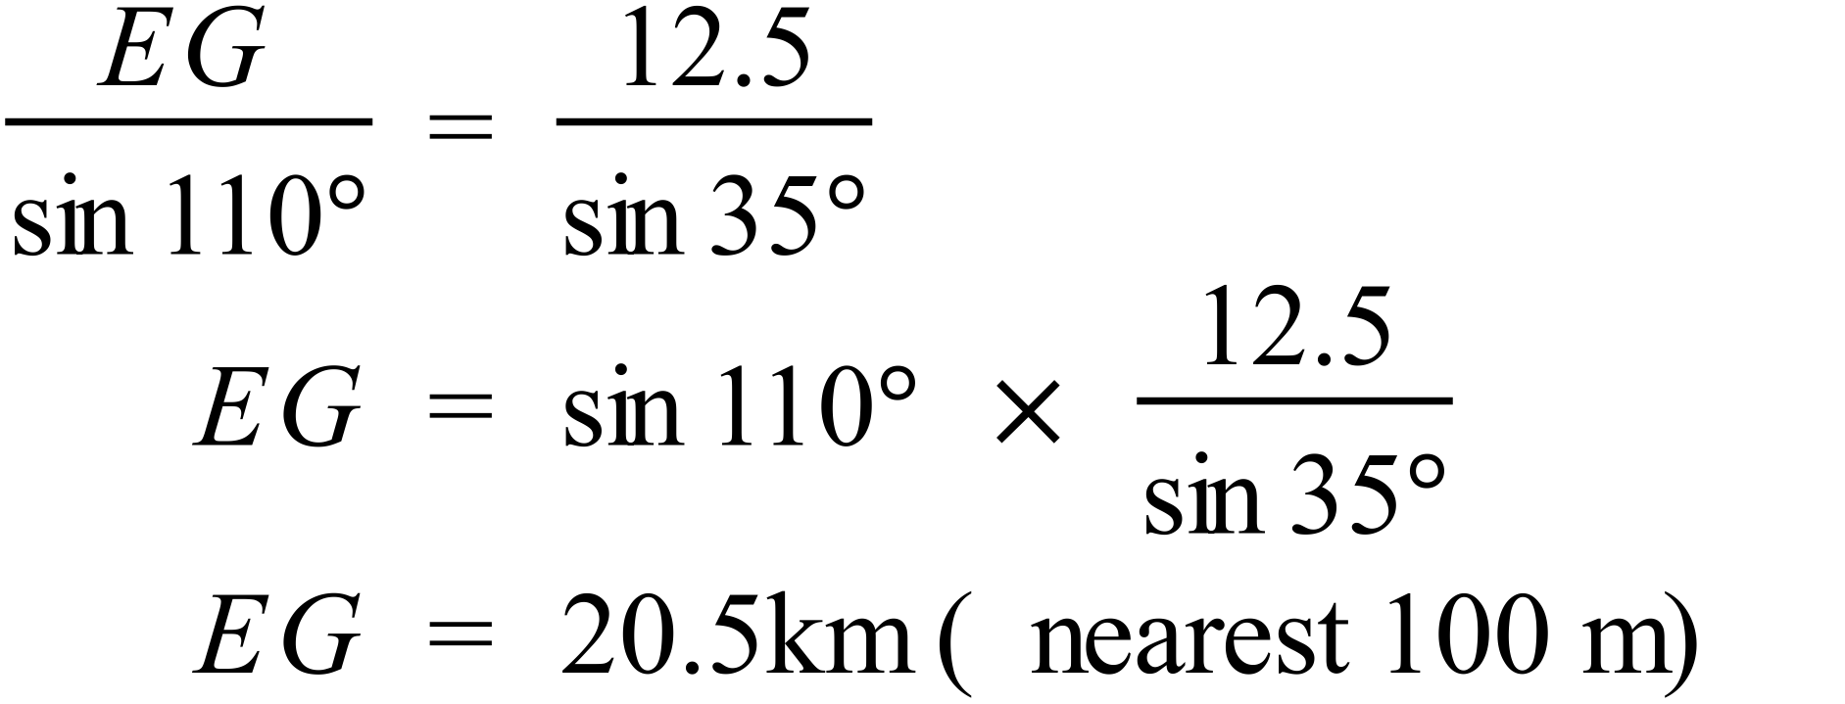 |  |  | 1 mark for correct answer
 | (b)  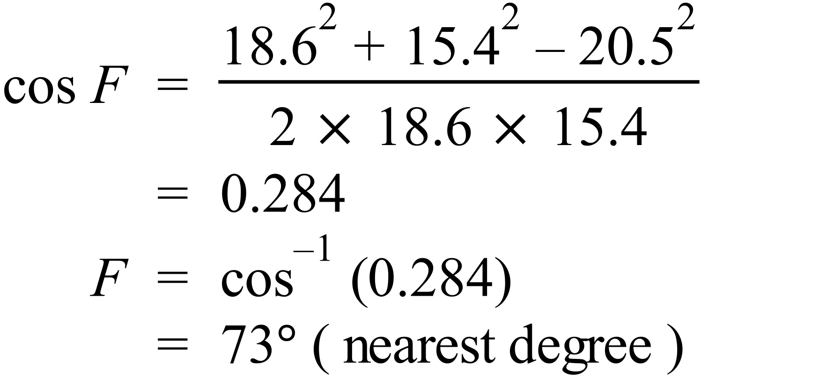 |  |  | 1 mark for correct answer
 | (c)  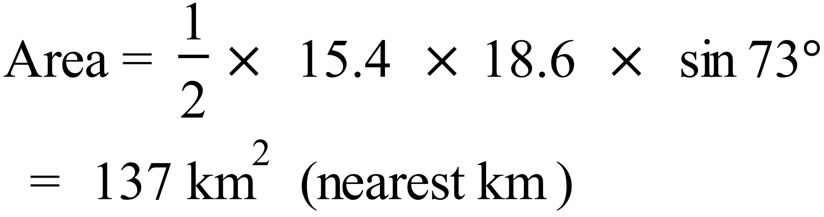 |  |  | 1 mark for correct answer
80. | 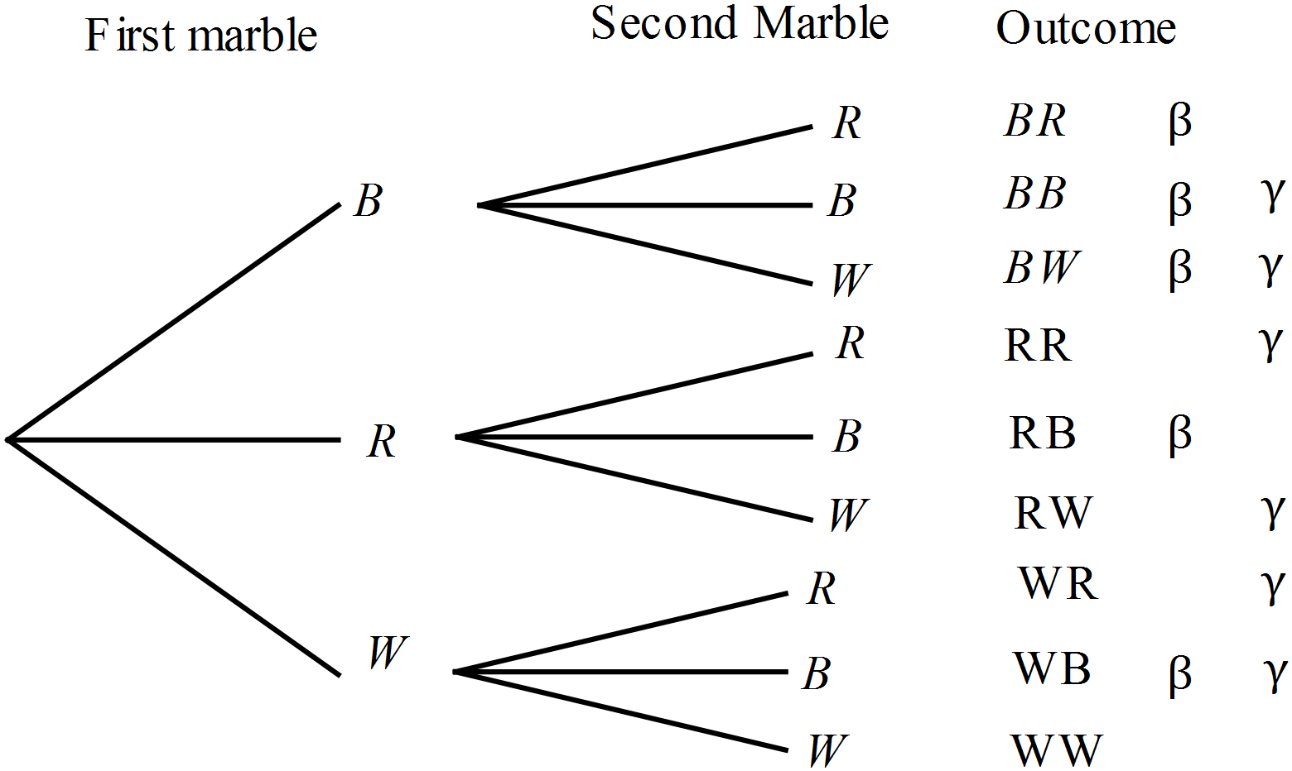(a) |  |  | 1 mark for correct diagram with outcomes  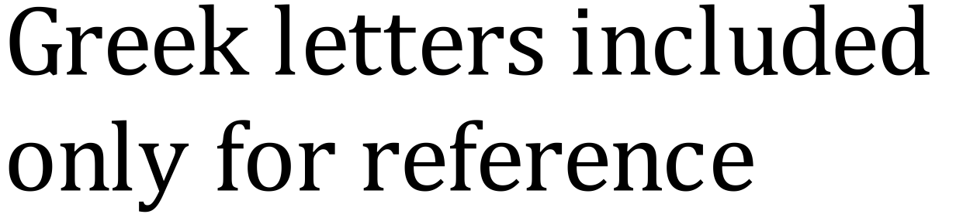
 | (b)  Those with a blue included are marked 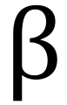  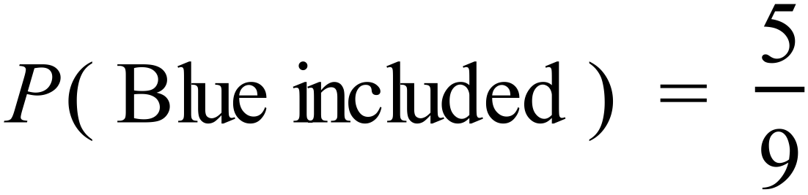 |  |  | 1 mark for correct answer
 | (c)  Those with a blue or red included but not both are marked 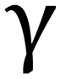  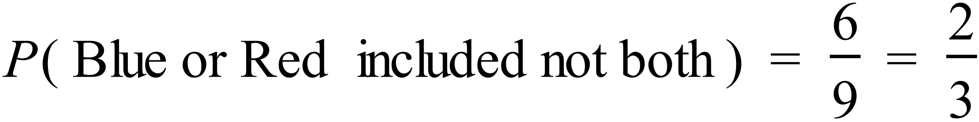 |  |  | 1 mark for correct answer
81. | 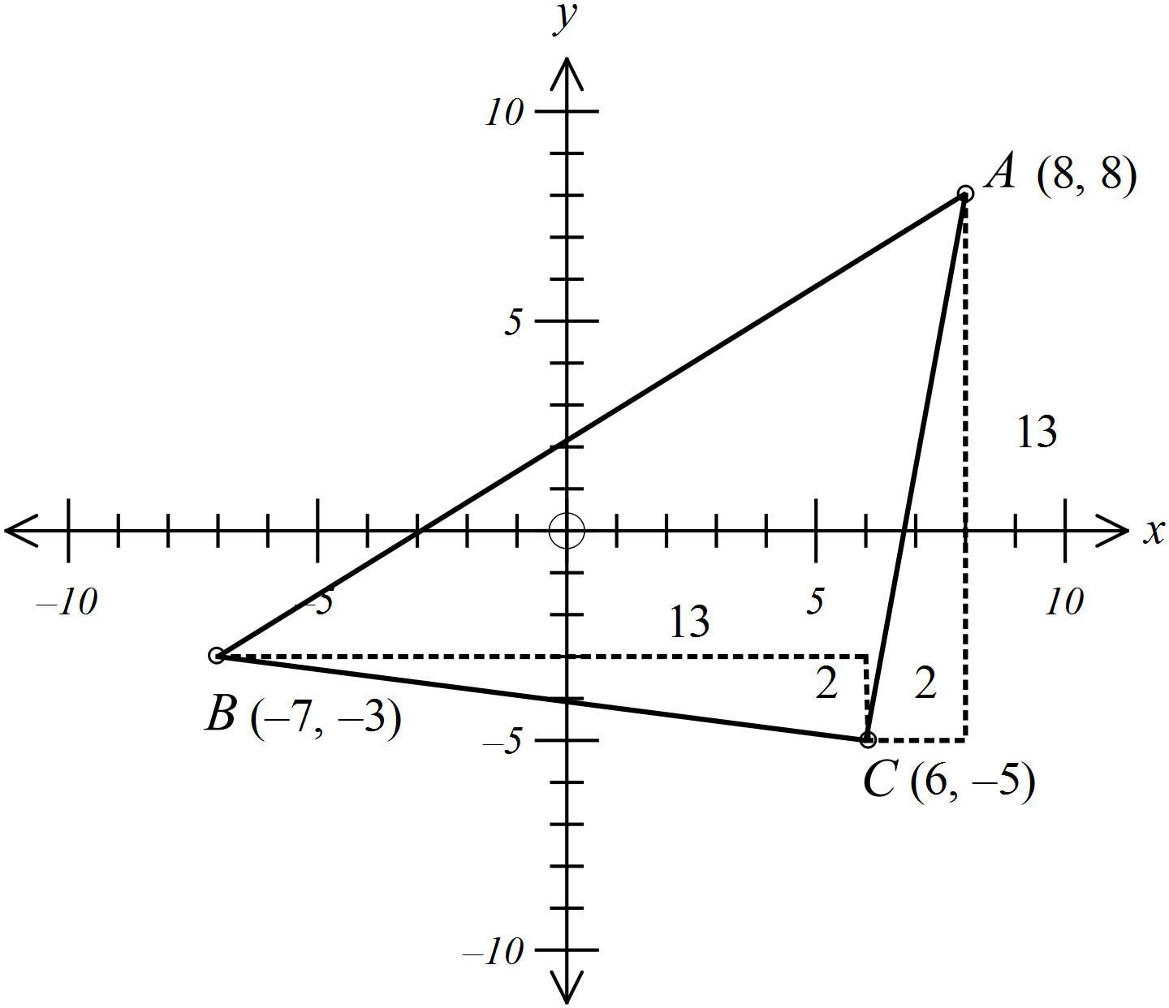  Sides which appear equal are AC and BC, so test these first.  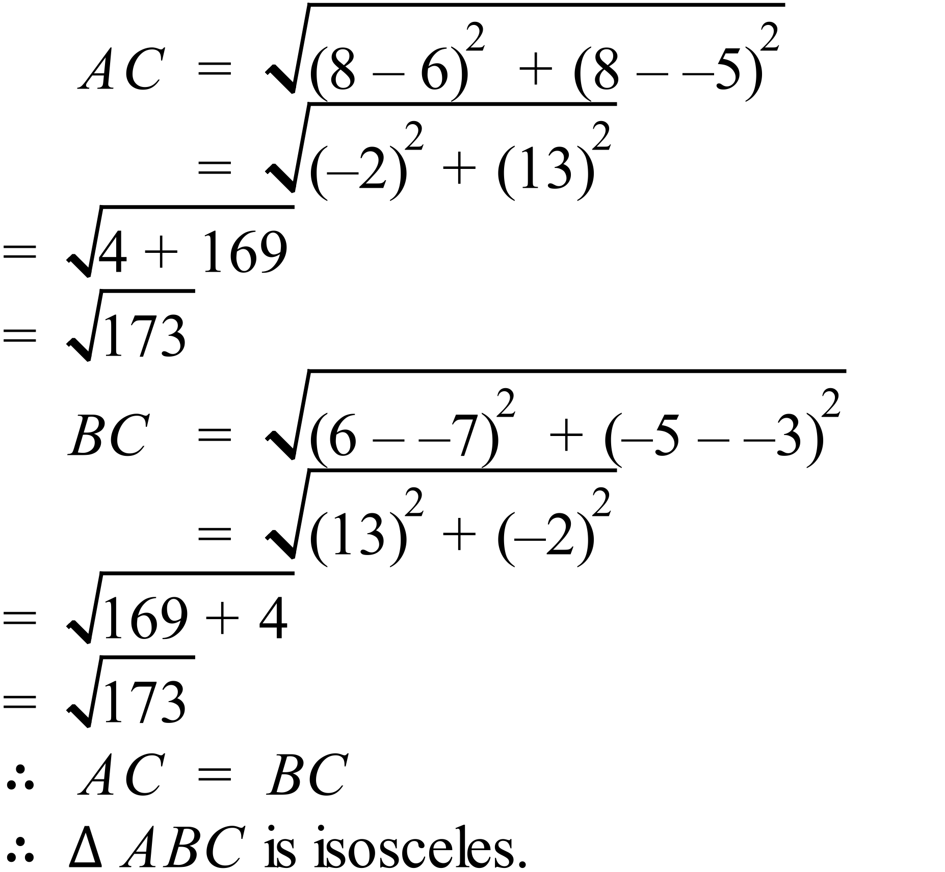 OR 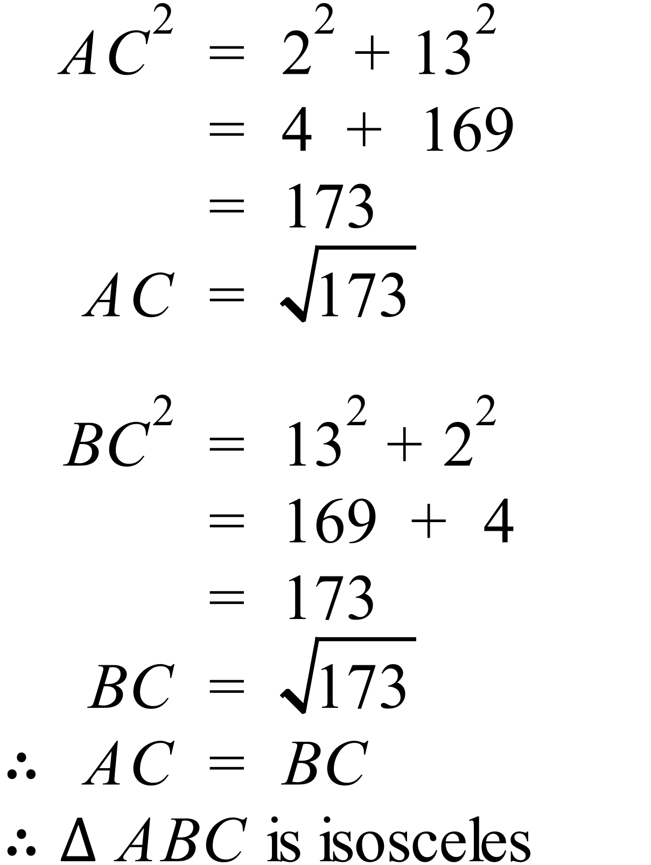 |  |  | 2 marks for solution which shows two sides are equal and hence that the triangle is isosceles.  Use of distance formula is preferred, but not essential.  1 mark for attempt to show sides equal using coordinate methods, with an error in calculation, or reasoning; for example if student finds gradients and uses this to show equal sides, whereas in fact it would show perpendicular sides.
82. | (a) 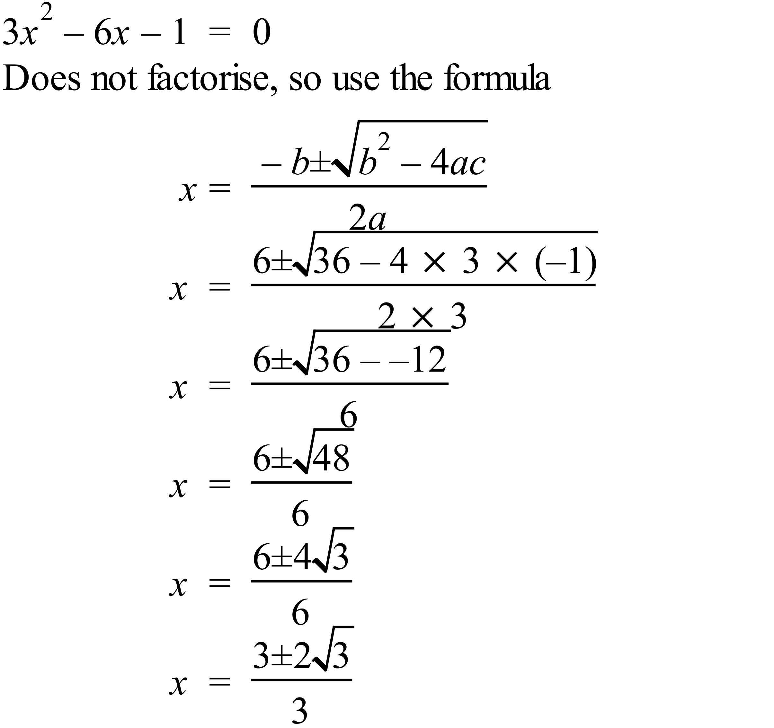 |  |  | 1 mark for correct answer of  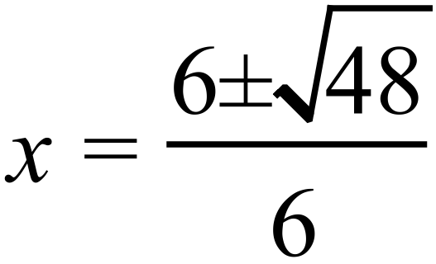  Simplest surd form is not needed for the mark, just supplied to compare with those who do go this far.
 | (b) 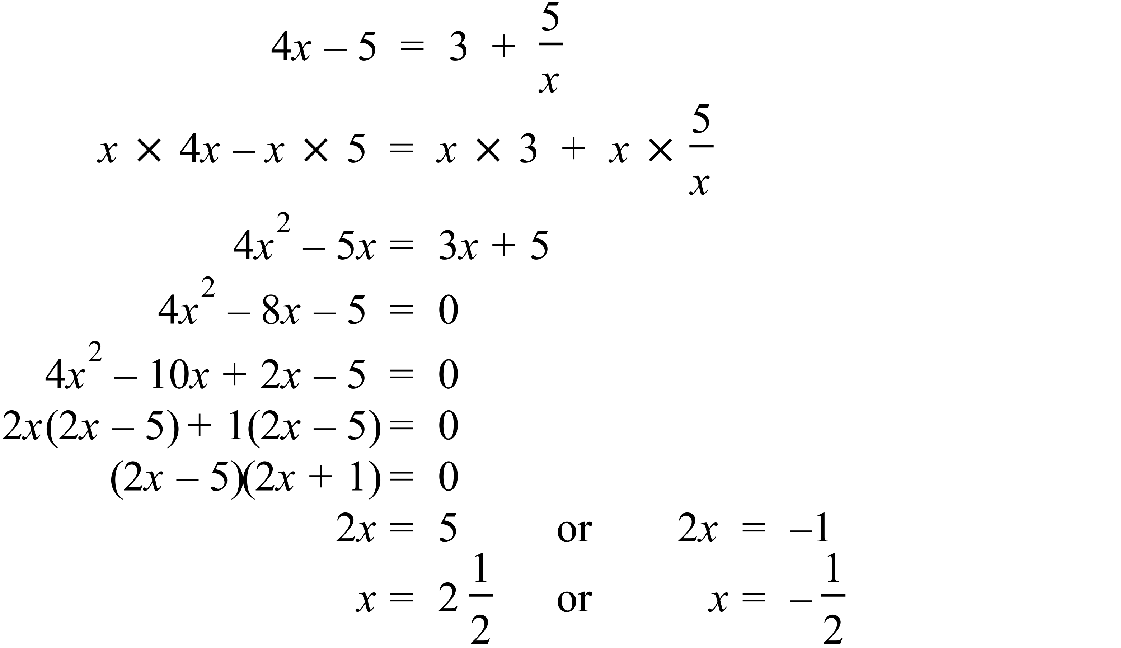 |  |  | 2 marks for both correct answers  1 mark for answer(s) with working that shows some correct algebraic manipulation toward answer.
83. | 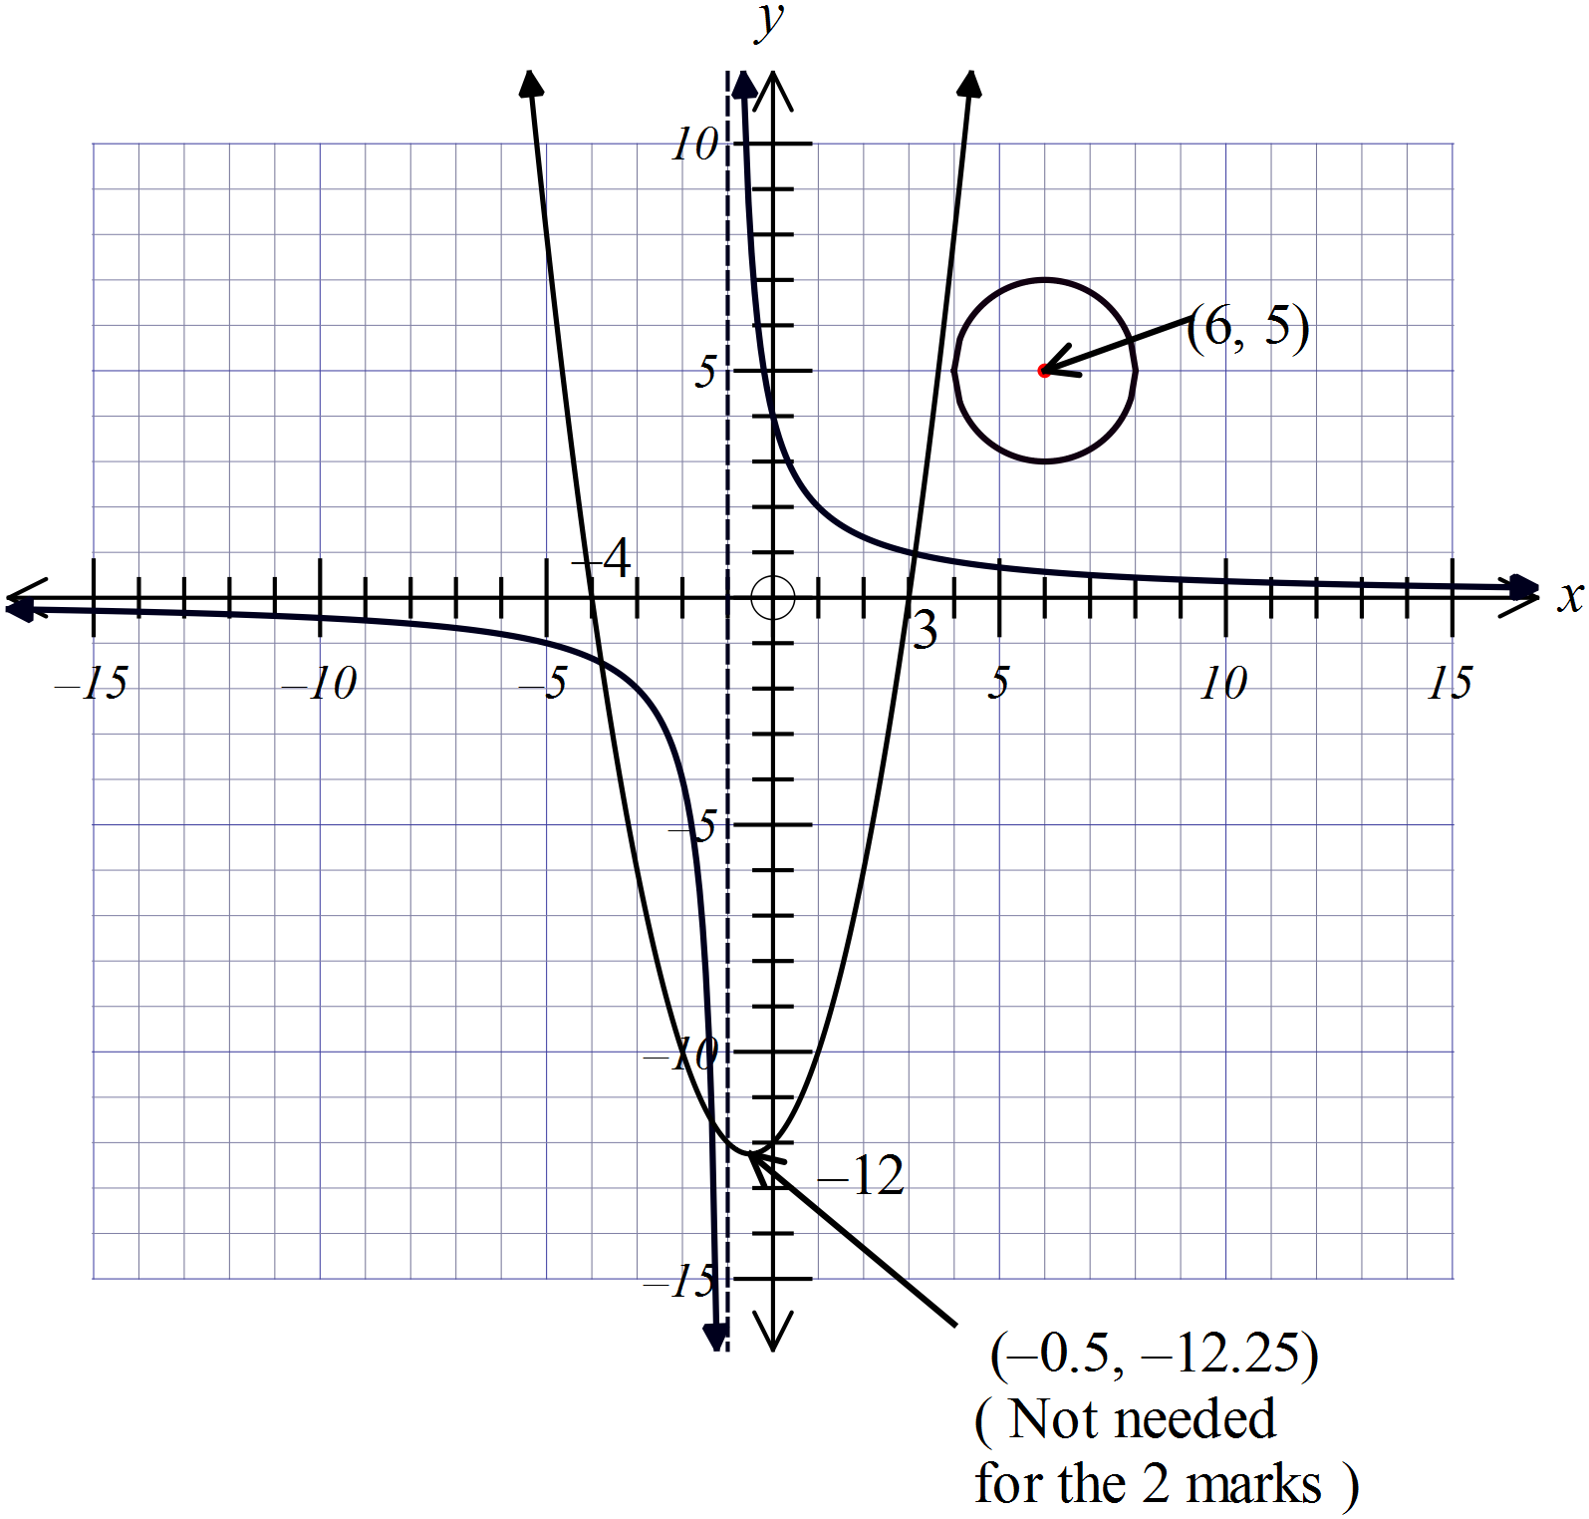 |  |  | (a)  2 marks for correct shaped parabola, including the x and y intercepts, exact vertex not required.  1 mark if factorised incorrectly to obtain intercepts, or otherwise a minor error in calculation or drawing.  (b) 1 mark for the correct circle with centre and radius correct.  (c) 1 mark for (3.0, 1.0) (-1.5, -11.5) and (-4, -1.5) [also accept (-3.5, -1.5)]

